

FAKE NEWS DETECTION SYSTEM USING FEATURE BASED OPTIMISED MSVM CLASSIFICATION
TruthGlow: a three-class screening aid built on PCA, the Firefly algorithm and a multi-class SVM
A project report submitted in partial fulfilment of the requirements for the award of the degree of
BACHELOR OF TECHNOLOGY
in
COMPUTER SCIENCE AND ENGINEERING
Submitted by
Neela Mojes | 23K91A05H1
Noor Saniya | 23K91A05H4
Malkajgiri Akshitha | 23K91A05E2
Maravajhala Radha Sri Aashritha | 23K91A05E7
Batch C6 (CSE-C)
Under the esteemed guidance of
K Rajasekhar Rao
[DESIGNATION]
DEPARTMENT OF COMPUTER SCIENCE AND ENGINEERING
[COLLEGE NAME]
[COLLEGE ADDRESS]
Academic year [ACADEMIC YEAR]

CERTIFICATE
This is to certify that the project report entitled "Fake News Detection System Using Feature Based Optimised MSVM Classification" is a bonafide record of the work carried out by Neela Mojes (23K91A05H1), Noor Saniya (23K91A05H4), Malkajgiri Akshitha (23K91A05E2), Maravajhala Radha Sri Aashritha (23K91A05E7), in partial fulfilment of the requirements for the award of the degree of Bachelor of Technology in Computer Science and Engineering, during the academic year [ACADEMIC YEAR], under my supervision.

Project Guide | Head of the Department | Principal
K Rajasekhar Rao | [HOD NAME] | [PRINCIPAL NAME]
[DESIGNATION] | Department of Computer Science and Engineering | [COLLEGE NAME]

External Examiner: [NAME AND SIGNATURE]
Place: [PLACE]
Date: [DATE]

DECLARATION
We hereby declare that the project report entitled "Fake News Detection System Using Feature Based Optimised MSVM Classification", submitted to the Department of Computer Science and Engineering, [COLLEGE NAME], in partial fulfilment of the requirements for the award of the degree of Bachelor of Technology in Computer Science and Engineering, is a record of original work carried out by us under the guidance of K Rajasekhar Rao, [DESIGNATION]. The results embodied in this report have not been submitted to any other university or institution for the award of any degree or diploma.

Neela Mojes 23K91A05H1
Noor Saniya 23K91A05H4
Malkajgiri Akshitha 23K91A05E2
Maravajhala Radha Sri Aashritha 23K91A05E7

Place: [PLACE]
Date: [DATE]

ACKNOWLEDGEMENT
We express our sincere gratitude to our project guide, K Rajasekhar Rao, [DESIGNATION], for valuable guidance, encouragement and constructive suggestions throughout this project.
We thank [HOD NAME], Head of the Department of Computer Science and Engineering, for providing the facilities and support needed to complete this work, and [PRINCIPAL NAME], Principal, [COLLEGE NAME], for the encouragement given to us.
We thank the project coordinators and all faculty and staff members of the department for their help, and our families and friends for their constant support.
We also acknowledge the authors of the base paper, the creators of the LIAR and LIAR2 datasets, and the developers of the open-source software used in this project (Python, scikit-learn, NumPy, SciPy, pandas, FastAPI, React and Vite).

Neela Mojes
Noor Saniya
Malkajgiri Akshitha
Maravajhala Radha Sri Aashritha

ABSTRACT
Fake news spreads faster than fact-checkers can respond, and many detectors force a claim into two classes or need large neural models. This project builds TruthGlow, which gives one of three verdicts - REAL, PARTIALLY TRUE or FAKE - with a confidence. Text becomes TF-IDF and stylometric features, compressed by Principal Component Analysis; the Firefly algorithm selects components and sets the parameters of a multi-class RBF support vector machine. A FastAPI layer and a React web application provide single and batch detection, analytics and retraining.
The shipped model was trained on a synthetic corpus, so its perfect scores are only a pipeline check. On real fact-checked statements (LIAR2, 3,000 training statements, 3 seeds) the pipeline reaches test macro-F1 0.429 ± 0.010 and accuracy 0.494 ± 0.008. The Firefly optimisation gave no gain over a default SVM (macro-F1 0.441) or an equal-budget random search, and logistic regression on plain TF-IDF scored 0.500. Server time is about 3.7 ms per article and 83 automated checks pass. Better accuracy at lower cost is therefore not demonstrated.
Keywords: Fake News Detection, multi-class support vector machine (msvm), principal component analysis (pca), firefly algorithm, metaheuristic feature optimization, misinformation filtering.

TABLE OF CONTENTS
CERTIFICATE i
DECLARATION ii
ACKNOWLEDGEMENT iii
ABSTRACT iv
TABLE OF CONTENTS v
LIST OF FIGURES vii
LIST OF TABLES ix
LIST OF ABBREVIATIONS x
CHAPTER 1: INTRODUCTION 1
1.1 Domain and Background 1
1.2 Motivation 2
1.3 Problem Statement 2
1.4 Need for the Project 2
1.5 Objectives 3
1.6 Scope 3
1.7 Contributions 4
1.8 Limitations and Assumptions 5
1.9 Organisation of the Report 6
CHAPTER 2: LITERATURE SURVEY 7
2.1 Overview 7
2.2 Analysis of the Base Paper 7
2.3 Related Work by Theme 9
2.4 Datasets and Algorithms Used in This Project 11
2.5 Strengths and Limitations of the Surveyed Approaches 12
2.6 Sources Named in the Project Survey 12
2.7 Research Gap 13
CHAPTER 3: FEASIBILITY STUDY 14
3.1 Technical Feasibility 14
3.2 Economic Feasibility 15
3.3 Operational Feasibility 15
3.4 Schedule Feasibility 16
3.5 Advantages and Constraints 16
CHAPTER 4: SYSTEM REQUIREMENTS AND ANALYSIS 18
4.1 Existing System and Its Limitations 18
4.2 Proposed System and Its Advantages 18
4.3 Functional Requirements 19
4.4 Non-Functional Requirements 19
4.5 Hardware Requirements 20
4.6 Software Requirements 20
4.7 User Roles 21
4.8 Constraints and Assumptions 21
CHAPTER 5: SYSTEM DESIGN 22
5.1 Design Goals 22
5.2 System Architecture 22
5.3 High-Level Workflow 23
5.4 Data Flow Diagrams 24
5.5 UML Diagrams 25
5.6 Data Design 28
5.7 Algorithm Design 29
5.8 Module Design 30
5.9 User Interface Design 30
5.10 Design Decisions and Their Consequences 31
CHAPTER 6: METHODOLOGY AND SOFTWARE IMPLEMENTATION 32
6.1 Overall methodology 32
6.2 Dataset 33
6.3 Preprocessing and feature construction 35
6.4 Algorithm choice and justification 36
6.5 Mathematical formulation 37
6.6 Model architecture and training configuration 39
6.7 Application architecture 41
6.8 API design 42
6.9 Security and error handling 43
6.10 Installation and execution 44
CHAPTER 7: SYSTEM TESTING 46
7.1 Testing strategy 46
7.2 Unit testing of the library 46
7.3 Integration testing of the API 47
7.4 Functional testing 48
7.5 Security, validation and edge-case testing 48
7.6 Performance testing 49
7.7 User interface testing 50
7.8 User acceptance testing 51
7.9 Defects and limitations found by testing 51
7.10 Limits of the testing done 51
CHAPTER 8: RESULTS AND OUTPUT SCREENS 52
8.1 Experimental set-up 52
8.2 Output screens 53
8.3 Model performance 56
8.4 Comparison with the base paper 61
8.5 Sample inputs and outputs, success and failure analysis 62
8.6 Limitations of these results 63
8.7 Objectives against outcomes 63
CHAPTER 9: CONCLUSION 64
9.1 Summary 64
9.2 Objectives achieved 64
9.3 Key findings 64
9.4 Practical applications 65
9.5 Known limitations 65
CHAPTER 10: FUTURE SCOPE 66
10.1 Improvements to the model 66
10.2 Improvements to the application 66
10.3 Scalability and deployment 67
10.4 Further research 67
REFERENCES 68
APPENDIX A: IMPORTANT CODE 70
A.1 Text cleaning (`src/preprocessing.py`) 70
A.2 Firefly fitness and main loop (`src/firefly.py`) 70
A.3 Pipeline: features, PCA and the final classifier (`src/pipeline.py`) 70
A.4 Prediction endpoint (`backend/main.py`) 71
A.5 Background retraining (`backend/main.py`) 71
APPENDIX B: INSTALLATION AND USER GUIDE 73
B.1 Requirements and start 73
B.2 Using the screens 73
B.3 Checks and troubleshooting 74
APPENDIX C: ADDITIONAL SCREENS 75

LIST OF FIGURES
Figure 1: High-level workflow of the system: the training path and the inference path. 4
Figure 2: System architecture of TruthGlow: presentation, application and domain tiers over two file stores. 22
Figure 3: High-level workflow: the training path (offline or from the Retrain screen) and the inference path. 23
Figure 4: Level 0 data flow diagram: the system as one process with three external entities. 24
Figure 5: Level 1 data flow diagram: four processes and two data stores. 24
Figure 6: Level 2 data flow diagram: the seven steps inside process 3.0, Train / retrain model. 25
Figure 7: UML class diagram of the main classes and modules. 25
Figure 8: Sequence diagram of one detection request, from the Detect screen to the SVM and back. 26
Figure 9: Sequence diagram of retraining: upload, background job, polling and hot swap. 27
Figure 10: Use case diagram: seven use cases and two actors. 27
Figure 11: Entity-relationship diagram of the data model; the product has no SQL database. 28
Figure 12: Feature pipeline: the shape of one article's representation after each stage. 29
Figure 13: Flowchart of the core algorithm: (A) the Firefly search and (B) the final model and inference. 29
Figure 14: Detect screen with a real LIAR2 test statement entered. 31
Figure 15: Retrain screen with a 600-row labelled CSV attached. 31
Figure 16: Shape of the data after each stage of the feature pipeline. 33
Figure 17: Flowchart of the Firefly search and of the final model. 39
Figure 18: Feature counts after each stage (mean of three runs). 40
Figure 19: Best fitness per generation for the three runs; dotted lines mark the best fitness of the equal-budget random search of the same run. 41
Figure 20: Training time of the pipeline stages and comparison models (log scale). 50
Figure 21: Landing page: tagline, live-demo card (clickbait example FAKE, 69.9 %) and the technique strip. 53
Figure 22: About: the four pipeline steps, the three classes and the loaded model (3,000 documents, 4025 to 300 to 154 features, 48.67 % / 0.4134). 53
Figure 23: FAKE-labelled statement ("Photo shows Ron DeSantis holding a shirt that says, 'Your mask is as useless as Joe Biden.'"): verdict FAKE, 83.8 %, 26 ms. 54
Figure 24: REAL-labelled statement ("In 1935, more than 50% of the elderly population lived in poverty. Today that poverty rate stands officially at 9.4%."): verdict REAL, about 54 %, 174 ms. 54
Figure 25: Half-true statement about New Hampshire's unemployment rate: verdict PARTIALLY TRUE shown with 47.2 % confidence, while the tallest bar is FAKE. 54
Figure 26: False statement about the signers of the Declaration of Independence: verdict REAL, 53.4 % - a wrong answer. 54
Figure 27: Batch check after choosing liar2_test_sample.csv: 120 rows, 3 columns, first 10 rows previewed. 55
Figure 28: Batch results: 120 articles screened (REAL 44, PARTIALLY TRUE 24, FAKE 52), distribution chart and results table. 55
Figure 29: Analytics (top): accuracy 48.67 %, macro-F1 0.4134, features 4025 to 154, 442.3 s; PCA keeps 29.1 % of the variance; gain from optimisation -2.67 pp. 55
Figure 30: Analytics (charts): confusion matrix of the 600-statement hold-out, Firefly curve (0.392 to 0.422), classification report, baseline against proposed. 55
Figure 31: Retrain: liar2_train_600.csv attached (71 KB), 4 fireflies, 3 generations, 4,000 TF-IDF features. 56
Figure 32: Retrain finished: 600 documents, PCA 300 to 147 components, accuracy 42.50 %, macro-F1 0.4113, 199 s. 56
Figure 33: Test accuracy (light bars) and macro-F1 (dark bars) of the proposed pipeline and its comparisons; whiskers: standard deviation over seeds. 57
Figure 34: Confusion matrix of the test split, seed 42. 58
Figure 35: Accuracy by confidence bin (seed 42). 58
Figure 36: Best Firefly fitness per generation; dotted lines: random search with the same budget. 59
Figure 37: Training time on a log scale (CPU only). 59
Figure 38: Left: macro-F1 of the demo model on its synthetic hold-out and on real LIAR2 statements, and of the LIAR2 model. Right: what the demo model predicts on the real test split. 60
Figure 39: Test statements per class for the verdict shown (SVC.predict) and for the class with the highest Platt probability. 60
Figure 40: Landing page, dark theme (demo model). 75
Figure 41: Landing page, light theme; the demo card scores the clickbait example FAKE, 89.5 %. 75
Figure 42: "How it works": step 2 of 4, compress with PCA. 75
Figure 43: Detect: clickbait example FAKE, 99.4 %, 2 ms. 75
Figure 44: Batch check on six demo articles: two per class, 99 to 100 %. 75
Figure 45: Analytics: accuracy 100 %, 596 to 57 features, PCA 136 components (95.2 %), 750 documents. 75
Figure 46: Analytics charts: perfect confusion matrix (50, 50, 50). 76
Figure 47: About screen of the demo model. 76
Figure 48: Retrain: a 60-row CSV, 10 fireflies, 6 generations. 76
Figure 49: Retrain running: 60 rows, 10 x 6 evaluations. 76
Figure 50: Retrain finished: PCA 10 components, Firefly kept 3, 100 %, 10 s. 76
Figure 51: LIAR2 retrain: the confirmation dialog "Replace the current model?" while the job starts. 76

LIST OF TABLES
Table 1: Abbreviations used in this report x
Table 2: Organisation of the report 6
Table 3: Results of the base paper [1] (as stated in the paper; binary Arabic task) 8
Table 4: Comparison of the surveyed work 10
Table 5: Approach families compared 12
Table 6: Additional sources named in the project literature survey 13
Table 7: Technical feasibility checks and what was measured 14
Table 8: Project phases (plan) and their products 16
Table 9: Functional requirements and how they are realised 19
Table 10: Non-functional requirements and the measured outcome 19
Table 11: Hardware used for development and measurement 20
Table 12: Software used 20
Table 13: Persistent and transient data 28
Table 14: Modules and their responsibilities 30
Table 15: Screens 30
Table 16: Design decisions 31
Table 17: Mapping from the six LIAR2 labels to the three classes of the product 34
Table 18: The two data sources 34
Table 19: The 25 stylometric features, in column order 35
Table 20: Why each component was chosen, and what the measurements say 36
Table 21: Training configuration 40
Table 22: Firefly results per run (10 fireflies, 12 generations) 40
Table 23: Main files 42
Table 24: Endpoints 42
Table 25: Validation and safety measures 43
Table 26: Test layers and results 46
Table 27: Unit checks by area 46
Table 28: Smoke-test checks 47
Table 29: Functional scenarios 48
Table 30: API edge-case checks 49
Table 31: Single-article latency (milliseconds, 300 requests) 49
Table 32: Batch throughput (server time in seconds) 50
Table 33: Findings 51
Table 34: Test-split scores on LIAR2, three classes (mean ± standard deviation over 3 seeds) 56
Table 35: Per-class test results of the proposed pipeline (mean ± std over 3 seeds) 57
Table 36: Firefly search against its baselines, per seed (test macro-F1 and training-split fitness) 58
Table 37: API response time and throughput (127.0.0.1, CPU idle, 300 sequential requests) 61
Table 38: The base paper and this project: what differs 61
Table 39: Real test statements and the model's output (seed 42) 62
Table 40: The six objectives of the project and what was achieved 63
Table 41: Common problems 74

LIST OF ABBREVIATIONS
Table 1: Abbreviations used in this report
Abbreviation | Expansion
API | Application Programming Interface
CLI | Command Line Interface
CPU | Central Processing Unit
CSV | Comma-Separated Values
CV | Cross-Validation
DFD | Data Flow Diagram
ER | Entity-Relationship
GPU | Graphics Processing Unit
HTTP | Hypertext Transfer Protocol
JSON | JavaScript Object Notation
LIAR / LIAR2 | Fact-checked statement benchmarks from PolitiFact (original and extended)
MSVM | Multi-class Support Vector Machine
NLP | Natural Language Processing
PCA | Principal Component Analysis
RBF | Radial Basis Function
REST | Representational State Transfer
SMOTE | Synthetic Minority Over-sampling Technique
SPA | Single-Page Application
SQL | Structured Query Language
SVM | Support Vector Machine
TF-IDF | Term Frequency - Inverse Document Frequency
UI | User Interface
UML | Unified Modeling Language
OvR | One-vs-Rest

CHAPTER 1: INTRODUCTION
This chapter introduces the domain of the project, the motivation for building the fake news detection system, the problem it addresses, the objectives set for it, the scope that was actually delivered, the contributions, and the limitations and assumptions that govern every result reported later. It closes with a map of the rest of the report.

1.1 Domain and Background
Fake news is deliberately fabricated or misleading content presented as news. It is not new, but online platforms have changed its scale and speed: anyone can publish, sharing costs nothing, and recommendation feeds reward content that attracts attention. A large-scale study of rumour cascades on Twitter found that false stories travelled farther and faster than true ones [17], and surveys of the field treat the problem as one of the main open issues of social media [16, 18]. Professional fact-checkers examine claims one at a time, which is accurate but slow, so most false claims are read, believed and passed on long before a verdict is published.
Automatic fake news detection is the branch of natural language processing that tries to help. A classifier reads the text of a headline, a claim or an article and predicts whether it is trustworthy. Early work used hand-made linguistic and n-gram features with classical learners [19, 20]; later work uses contextual embeddings from transformers [23, 1]. A parallel line of work studies the style of deceptive text, such as exaggerated wording, capital letters and sensational vocabulary [21, 22].
Most detectors treat the task as binary: a text is either real or fake. Real fact-checking is not binary. Organisations such as PolitiFact grade claims on a scale from true to pants-on-fire, and the LIAR family of datasets keeps these six grades [5, 4]. A claim can mix accurate figures with an exaggerated conclusion, and a system that forces such a claim into one of two boxes either hides the nuance or misleads. This project therefore works with three verdicts: REAL, PARTIALLY TRUE and FAKE.
The technical idea of the project follows the batch title. Text is converted into a high-dimensional feature vector (word and word-pair weights plus a few stylometric measures); Principal Component Analysis (PCA) [10, 11] compresses it; the Firefly algorithm [6, 7], a swarm metaheuristic, chooses which compressed components to keep and sets the parameters of the classifier; and a multi-class Support Vector Machine (MSVM) [8, 9] makes the decision. The expectation behind the design, stated in the batch abstract, is a computationally light pipeline that does not need a graphics processor or a large pre-trained language model.

1.2 Motivation
Three observations motivate the project. First, the volume of published text is far beyond what human fact-checkers can examine, so a cheap automatic screening aid that flags suspicious items for a human is useful even if it is imperfect. The system built here is explicitly such an aid: its screens say that it judges writing style and vocabulary, not facts.
Second, many published detectors rely on large neural models that need specialised hardware. The base paper chosen for this batch uses CAMeLBERT embeddings on a Tesla T4 graphics processor [1]. A pipeline of TF-IDF, PCA and an SVM can be trained and run on an ordinary laptop, and the batch asks whether feature reduction plus metaheuristic tuning can deliver comparable accuracy at lower cost. Whether it does is an empirical question, and the project sets out to answer it with measurements rather than assumptions.
Third, a classifier in a notebook is not a tool. A person who wants to screen one article, a spreadsheet of articles, or to retrain the model on their own labelled data needs an application. The team therefore delivered the whole chain: a web interface (named TruthGlow), a service layer and the library, together with a command line and a Streamlit app kept from the first version.

1.3 Problem Statement
Given the text of a news item or claim, assign it one of three verdicts - REAL, PARTIALLY TRUE or FAKE - with a confidence, using a computationally light pipeline (TF-IDF and stylometric features reduced by PCA, with the Firefly algorithm choosing the feature subset and the SVM parameters), and report honestly how accurate and how costly it is, through an application that a non-expert can run.
The project's own problem analysis lists four difficulties that the design must respect:
• Fabricated news reaches large audiences before any fact-check is published.
• High-dimensional text features make classifiers slow and prone to overfitting.
• Default classifier parameters give suboptimal accuracy on noisy news text.
• Many published detectors report accuracy without addressing computational cost.

1.4 Need for the Project
A usable screening tool has to satisfy several needs at once, and existing work tends to satisfy only some of them. It must give a graded verdict rather than a binary one, because partly true claims are common. It must be cheap to train and fast to run, so that it can be retrained on new topics, which change every week, without special hardware. It must say how confident it is, so that a reader knows how much weight to give the verdict. It must be usable by a person who is not a machine-learning engineer, and it must be reproducible: the data, the preprocessing, the optimisation and the measurements have to be inspectable and repeatable.
The survey in Chapter 2 shows that the strongest recent systems use transformer embeddings [1, 2], while the gap named in the batch survey is a computationally light pipeline in which feature reduction and metaheuristic tuning replace model size. The project is built to test that idea and to report plainly what it achieves.

1.5 Objectives
The six objectives approved for the project are:
1. Assemble a labelled dataset of genuine and fabricated news articles.
2. Preprocess the text with tokenisation, stop-word removal, stemming and vectorisation.
3. Apply Principal Component Analysis to reduce feature dimensionality.
4. Use the Firefly algorithm to optimise feature selection and MSVM parameters.
5. Train a Multi-class Support Vector Machine classifier on the optimised feature set.
6. Evaluate accuracy, precision, recall and F1-score against unoptimised baselines.
Chapter 8 measures each objective against the outcome. In short, the system was built and every stage exists; the dataset was assembled from the public LIAR2 benchmark (and a synthetic demonstration corpus for the shipped model); stemming, listed in objective 2, was not implemented; and for objectives 4 to 6 the evaluation shows that the Firefly optimisation did not give a measurable gain over its baselines on real data, so the aim of better accuracy at lower cost is not demonstrated.

1.6 Scope
In scope are the following items, all of which exist in the delivered code base:
• a text-classification library with three classes (REAL, PARTIALLY TRUE, FAKE): text cleaning, TF-IDF with word pairs, 25 stylometric features, standardisation and PCA;
• a Firefly optimiser that jointly selects PCA components and sets the SVM parameters C and gamma, with a size penalty on the selected subset;
• a multi-class RBF SVM with balanced class weights and probability output, with a default-parameter SVM as the built-in baseline;
• loaders for CSV files in several layouts (text and label columns, title plus text, LIAR statements) and a built-in synthetic demonstration corpus;
• a FastAPI service with eight endpoints (health, model information, samples, single prediction, batch preview and run, retraining and its status);
• a React web application with a landing page and five application screens (Detect, Batch check, Model analytics, Retrain, About), about 4,865 lines of TypeScript, plus the original command line and Streamlit app;
• 83 automated checks and a set of scripts that regenerate every measured number in this report from the real LIAR2 data.
Out of scope are fact checking against external sources, image or video analysis, languages other than English, social-network or propagation features, user accounts, deployment to a public server and any field study with real readers.
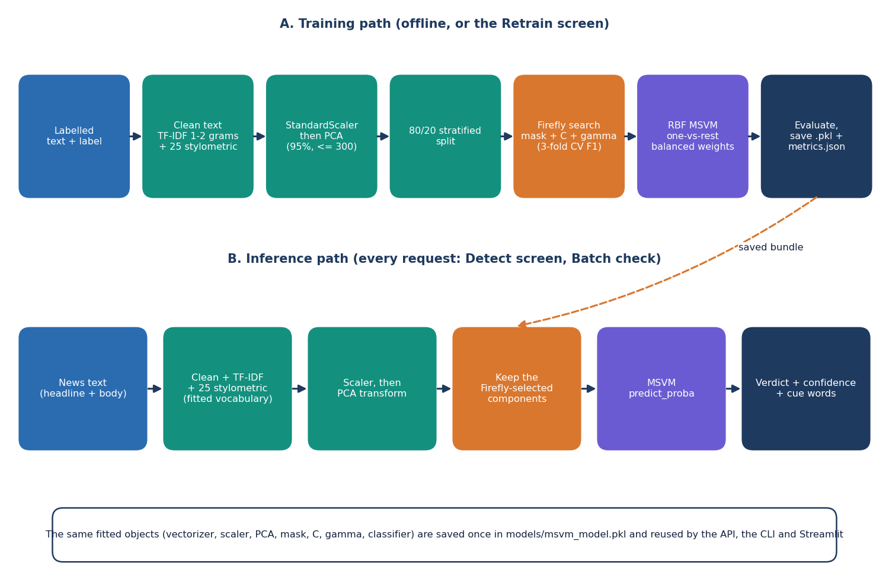
Figure 1: High-level workflow of the system: the training path and the inference path.

1.7 Contributions
The contributions of the work are practical and are stated at the level the evidence supports:
1. An end-to-end, runnable PCA + Firefly + MSVM pipeline with an explicit PARTIALLY TRUE class, packaged as a web application with single and batch detection, model analytics and in-browser retraining, in addition to the command line and Streamlit versions.
2. A joint Firefly search over the PCA-component mask and the SVM parameters C and gamma, with a penalty on the share of components kept.
3. A reproducible real-data benchmark on LIAR2 (3,000 training statements, 2,296 test statements, 3 seeds) that compares the proposed pipeline with a default SVM, a Firefly mask without parameter tuning, an equal-budget random search and linear text classifiers: the proposed pipeline reaches a test macro-F1 of 0.429 ± 0.010 and accuracy 0.494 ± 0.008.
4. Honest findings: the optimiser's gain over its baselines is within the seed-to-seed noise; PCA capped at 300 components keeps only about 29% of the variance of the real-text features; and the verdict and the displayed probabilities disagree on 49% of real test statements.
5. Measured cost: about 3.7 ms of server time per article and about 1.2 s for the 2,296-statement test split, on a CPU-only machine.
6. Complete documentation and a verification script that checks the documents against the code and the measurements.

1.8 Limitations and Assumptions
The main limitations are stated here once and repeated where they matter:
• The model that ships with the project was trained on a synthetic template corpus of 750 documents. Its perfect scores (1.000) are a pipeline check, not evidence; on real LIAR2 test statements the same model scores accuracy 0.192 and macro-F1 0.155.
• All real-data results come from a 3,000-statement training subsample (the Firefly search needs thousands of SVM fits) and 3 seeds; no significance test was run.
• On real data the system is a weak classifier: macro-F1 about 0.43. PARTIALLY TRUE is the hardest class and the verdict and probabilities are inconsistent in many cases.
• Stemming, named in the second objective, is not implemented; the pipeline uses cleaning, stop-word removal and TF-IDF only.
• Only the statement text is used. No source, speaker, date or evidence is considered, so the system judges style and vocabulary, not facts.
• No other dataset (such as ISOT), no user study and no load test were carried out.
The assumptions are that the input is English text of at least five words, that labels in a retraining file follow the three project classes (or the LIAR and 0/1/2 conventions the loader recognises), and that the user runs the system on a personal computer. The system is a research and teaching prototype and is not a certified fact-checking service.

1.9 Organisation of the Report
Table 2: Organisation of the report
Chapter | Title | Content
1 | Introduction | Domain, motivation, problem, objectives, scope, contributions, limitations
2 | Literature Survey | Base paper analysis, related work by theme, datasets and algorithms, research gap
3 | Feasibility Study | Technical, economic, operational and schedule feasibility
4 | System Requirements and Analysis | Existing and proposed system, functional and non-functional requirements, environment
5 | System Design | Architecture, workflow, data-flow diagrams, UML, data model, modules, interface
6 | Methodology and Software Implementation | Dataset, preprocessing, PCA, Firefly, MSVM, API, security, installation
7 | System Testing | Strategy and results of unit, integration, functional, security and performance tests
8 | Results and Output Screens | Measured results, comparison with the base paper, screens, failures, objectives versus outcome
9 | Conclusion | Summary, findings, applications, known limitations
10 | Future Scope | Improvements, features, scalability, research directions

References and three appendices (important code, installation and user guide, additional screens) follow Chapter 10.

CHAPTER 2: LITERATURE SURVEY

2.1 Overview
This chapter reviews the work on which the project builds and against which it must be judged. It starts with the base paper assigned to the batch [1], analyses it in detail, and then groups related work by theme: datasets and benchmarks, classical and feature-based detection, deep and transformer models, and optimisation and feature selection. It then describes the datasets and algorithms the project itself uses, summarises the strengths and limitations of the approaches, lists the additional sources named in the project's literature survey, and ends with the research gap.
Two comments on method. Numerical results are quoted only where we read them in the paper itself (this holds for the base paper, for the experimental comparison [2], for the Bayesian-optimisation paper [3] and for the LIAR2 dataset card) or where a publisher's record states the bibliographic details. For the other works the table gives the approach and the stated limitation without reproducing figures that we did not verify.

2.2 Analysis of the Base Paper
The base paper is "An algorithmic system for Arabic fake news detection using neural networks and transformer embeddings with class weighting" by Saad, Abdelrazek and Abdelmaksoud, published in Scientific Reports in 2026 [1]. Its subject is binary detection of fake news in Arabic. Its starting observation is that Arabic is under-explored because datasets are limited and the language is morphologically and semantically complex, and that existing Arabic systems rely on classical learners, data-level resampling (undersampling, oversampling, SMOTE) or transformer models, each with a known weakness: synthetic noise in SMOTE, over-fitting in oversampling and data loss in undersampling.

2.2.1 Problem and idea
The authors argue that algorithm-level class weighting, which changes the loss function instead of the data, has been little studied for Arabic fake news. Their framework has three parts. First, class weighting counters the imbalance between real and fake articles. Second, CAMeLBERT is used as a fixed feature extractor, giving contextual embeddings that they report as better than TF-IDF and bag-of-words. Third, a neural-network classifier models the non-linear relations in the dense embedding space. The paper compares four Arabic transformers (CAMeLBERT, AraBERT, AraELECTRA and MARBERTv2) and four imbalance strategies (class weighting, undersampling, oversampling and SMOTE), and adds LIME and SHAP analyses to explain the classifier.

2.2.2 Data and experimental set-up
The dataset has 7,474 Arabic news articles from 2015 to 2025. About 45 % come from established news agencies, about 30 % from blogs, open Facebook pages and user posts that the team labelled against fact-checking platforms, and about 25 % from benchmark datasets such as WELFake and LIAR whose articles were translated into Arabic and post-edited by a native speaker. Labelling quality was checked by double-coding a subset of 500 samples, giving a Fleiss' kappa of 0.80. The split is 80 % training and 20 % testing with a fixed random state of 44. CAMeLBERT inputs are limited to 128 tokens; the classifier is trained with the Adam optimiser and binary cross-entropy weighted by class, with batch size 16, learning rate 0.0005, 256 dense units, dropout 0.2 and 10 epochs. Experiments ran on a Tesla T4 graphics processor with 12 GB of memory.

2.2.3 Results reported
Table 3: Results of the base paper [1] (as stated in the paper; binary Arabic task)
Configuration | Reported value
TF-IDF (2,000 uni- and bigram features) + neural network | accuracy 90.97 %, F1 92.20 %
TF-IDF + decision tree | accuracy 88.03 %, F1 89.73 %
CAMeLBERT embeddings + neural network | accuracy 93.98 %, F1 95.05 %, recall 99.08 %, ROC-AUC 98.65 %
CAMeLBERT + SMOTE + neural network | F1 95.71 %
CAMeLBERT + undersampling + neural network | accuracy 92.51 %
CAMeLBERT + class weighting + neural network (proposed) | accuracy 95.52 %, F1 96.19 %, precision 95.48 %, recall 96.90 %

2.2.4 Strengths and stated limits
The paper is careful in several respects: it validates label quality with an agreement statistic, it compares several transformers and several imbalance techniques under one protocol, it reports accuracy, precision, recall, F1 and ROC-AUC, it keeps a TF-IDF baseline for reference, and it explains predictions with LIME and SHAP. The authors name as future work the assessment of cross-domain generalisation and the feasibility of real-time deployment, and they describe the system as suitable for resource-constrained applications although the reported hardware is a graphics processor.

2.2.5 Relation to this project
It is important to be precise about what the project takes from this paper and what it does not. It takes three ideas: handle class imbalance at the algorithm level (the SVM here uses balanced class weights), report several metrics instead of accuracy alone, and compare against baselines. It does not use transformer embeddings, it works in English, and its task has three classes instead of two. The data, language, task and compute therefore differ, and the numbers of the two works are not comparable; Chapter 8 presents the comparison as context only. The base paper's own TF-IDF-plus-neural-network baseline (accuracy 90.97 %) shows that classical features are a respectable starting point on its data, which is the premise on which the present pipeline is built.

2.3 Related Work by Theme

2.3.1 Datasets and benchmarks
Wang introduced LIAR, a collection of short statements from PolitiFact with six truthfulness labels, as a benchmark for fine-grained fake news detection [5]. Xu and Kechadi extended it to LIAR2, about 23 thousand statements split 18,369 / 2,297 / 2,296 for training, validation and testing [4]; LIAR2 is the dataset used for every real measurement in this project. Dell'Oglio et al. compared 12 approaches on 10 public datasets after harmonising labels to real and fake [2]. They found that LIAR-PLUS, the six-class LIAR extended with justification text, was the most challenging dataset for nearly all models: in-domain logistic regression scored an F1 of 0.56 and a support vector machine 0.57, and a fine-tuned transformer trained on a generic aggregate could not exceed an F1 of 0.57 on it. They attribute part of the difficulty to the blurry boundary between fabrication and half-truth, which is exactly the boundary the third class of this project tries to represent.

2.3.2 Classical and feature-based detection
Ahmed, Traore and Saad used n-gram TF-IDF features with several classical learners, among which a linear SVM was strong [19]. Perez-Rosas et al. built fake-news corpora and showed that linguistic features carry signal [20]. Potthast et al. showed that style-based features can separate hyperpartisan and mainstream news, although style is a weak proxy for truthfulness [21]. Rashkin et al. analysed the language of different degrees of falsehood in political fact-checking and in propaganda, hoax and satire, which supports giving middle grades such as half-true their own class [22]. Al-Tarawneh et al. compared TF-IDF, Word2Vec and FastText with classical and deep classifiers [26]. The 25 stylometric features of this project (capital letters, exclamation and question marks, digits, lexicon ratios) follow this line.

2.3.3 Deep and transformer models
BERT [23] made contextual embeddings the standard input for text classifiers, and the base paper uses a language-specific variant [1]. Huang et al. combined TF-IDF features with a Transformer and a bidirectional recurrent unit and tuned it with Bayesian optimisation, reporting 99.67 % test accuracy without and 99.73 % with the Bayesian step [3]. The comparison of Dell'Oglio et al. [2] shows that fine-tuned models do well in-domain and degrade across domains. Near-perfect scores on a single corpus therefore say little about harder fact-checking text, a caution that applies, in a different way, to the 100 % score of this project's own synthetic demonstration model.

2.3.4 Optimisation and feature selection
The Firefly algorithm was proposed by Yang as a swarm method in which each candidate solution is a firefly whose brightness is its fitness and which moves towards brighter ones [6, 7]. Xue et al. surveyed evolutionary computation for feature selection [24], and Zhang et al. applied firefly optimisation to feature selection for classification and regression [25]. These works motivate using a metaheuristic to choose a feature subset and to tune a classifier at the same time, at the price of repeated model evaluations. Class imbalance, the other recurring difficulty, is reviewed by He and Garcia [15] and handled in this project by class weights.

2.3.5 Surveys
Shu et al. [16] and Zhou and Zafarani [18] organise the field by content, style, propagation and source, and Vosoughi et al. [17] document how false news spreads. They define the setting in which a text-only detector sits: it can use the content and style of the statement but not who said it, who shared it or what evidence exists.
Table 4: Comparison of the surveyed work
Work | Approach | Data | Reported result | Limitation
Saad et al. 2026 [1] (base paper) | CAMeLBERT contextual embeddings + neural network, class weighting for imbalance; compared with AraBERT, AraELECTRA, MARBERTv2 and resampling | 7,474 Arabic news articles (multi-source, part translated from LIAR / WELFake), binary real/fake, 80/20 split | F1 96.19 %, accuracy 95.52 %, precision 95.48 %, recall 96.90 % (Tesla T4 GPU); TF-IDF + NN baseline accuracy 90.97 % | Arabic, binary, GPU-based transformer; cross-domain generalisation and real-time use left as future work
Dell'Oglio et al. 2026 [2] | Experimental comparison of 12 approaches (classical ML, deep learning, transformers, cross-domain, LLMs) on 10 public datasets, labels harmonised to binary | 10 English datasets incl. LIAR-PLUS, Politifact, Isot | LIAR-PLUS is the hardest dataset for nearly all models: F1 0.56 (LR) and 0.57 (SVM) in-domain; fine-tuned models generalise poorly across domains | Binary harmonisation removes label nuance (no PARTIALLY TRUE class)
Huang et al. 2025 [3] | TF-IDF features, Transformer with BiGRU, Bayesian optimisation of hyper-parameters | A fake/real news corpus (details in the paper) | 99.67 % test accuracy (BiGRU Transformer), 99.73 % with Bayesian optimisation | Binary task; near-perfect score on its own data says little about harder fact-checking text
Xu and Kechadi 2024 [4] | Fuzzy deep hybrid network for fake news detection; releases LIAR2 | LIAR2: 18,369 / 2,297 / 2,296 statements, six labels | Introduces the LIAR2 benchmark used for every real measurement in this project | Deep model; the dataset card gives the split, not a cheap-pipeline baseline
Wang 2017 [5] | LIAR benchmark: short PolitiFact statements with six-way truthfulness labels | About 12.8 k statements | Text-only models score far below the usual fake/real benchmarks | Short statements, six fine-grained labels
Ahmed et al. 2017 [19] | N-gram TF-IDF features with classical classifiers (including linear SVM) | News article corpora | Linear SVM among the strongest classical choices on n-gram TF-IDF | Binary, article-level data
Rashkin et al. 2017 [22] | Linguistic analysis of varying degrees of falsehood in political fact-checking (LIAR-style scales) and of propaganda, hoax and satire | PolitiFact statements and news corpora | Shows that language cues differ between true, half-true and false content | Analysis and classifiers on word-category features
Potthast et al. 2018 [21] | Style-based (stylometric) features separate hyperpartisan and fake from mainstream news | BuzzFeed-Webis fact-checked news corpus | Style alone detects hyperpartisan style better than truthfulness | Style is a weak proxy for veracity
Zhang et al. 2018 [25]; Xue et al. 2016 [24] | Firefly-based and evolutionary feature selection for classification | Benchmark classification datasets | Metaheuristic feature selection can shrink feature sets at similar accuracy | Search cost; gains depend on the data

2.4 Datasets and Algorithms Used in This Project

2.4.1 Datasets
LIAR2 [4] is released under the Apache-2.0 licence and consists of PolitiFact statements labelled by professional fact-checkers with six grades: pants-on-fire, false, barely-true, half-true, mostly-true and true. The official split has 18,369 training, 2,297 validation and 2,296 test statements, with an average length of about 18 tokens. The project maps the grades to three classes: true and mostly-true to REAL, half-true to PARTIALLY TRUE, and barely-true, false and pants-on-fire to FAKE. The test split then has 602 REAL, 371 PARTIALLY TRUE and 1323 FAKE statements, so FAKE is the majority class (57.6%). Only the statement text is used; the speaker, the justification and the speaker's history counts are not, because they would leak the label. The product also contains a small synthetic template corpus used for a quick demonstration model; it is described in Chapter 6 and is not evidence of accuracy.

2.4.2 Algorithms
Text is weighted with TF-IDF [13], which scores a term high when it is frequent in a document and rare in the collection. The high-dimensional vectors are standardised and compressed with PCA [10, 11], which projects the data onto the orthogonal directions of largest variance. Classification uses the support vector machine of Cortes and Vapnik [8] with a radial-basis kernel, extended to several classes by a one-vs-rest or one-vs-one scheme [9]; the implementation is scikit-learn [14]. An SVM produces decision scores, and probabilities are obtained by Platt scaling [12], which fits a sigmoid to the scores by cross-validation.
The Firefly algorithm treats each candidate as a firefly with position x. The attractiveness of firefly j to firefly i falls with the squared distance between them, and firefly i moves towards any brighter firefly j with a random step:
beta = beta0 * exp(-gamma * r^2), x_i <- x_i + beta * (x_j - x_i) + alpha * (u - 0.5) (1)
In this project a position holds one logit per PCA component (a component is kept when its sigmoid exceeds 0.5), log10 of the SVM parameter C and log10 of the kernel width gamma. Brightness is the three-fold cross-validated macro-F1 on the training split minus a penalty proportional to the share of components kept. Chapter 6 gives the full formulation and the settings.

2.5 Strengths and Limitations of the Surveyed Approaches
Table 5: Approach families compared
Family | Strengths | Limitations for a light, three-class screening aid
N-gram TF-IDF with classical learners [19] | Cheap, fast, easy to retrain | Surface features; sensitive to vocabulary and topic
Stylometric and linguistic features [21], [22] | Cheap; capture exaggeration and tone | Style is a weak proxy for truth
Transformer embeddings and fine-tuning [1], [23] | Strong in-domain accuracy | Need pre-trained models and often a GPU; weak across domains [2]
Bayesian-optimised transformer [3] | Very high reported accuracy on its corpus | Binary task; says little about harder fact-checking text
Metaheuristic feature selection [24], [25] | Can shrink the feature set and tune parameters | Many model evaluations; gains depend on the data
Binary harmonised benchmarks [2] | Comparable across datasets | Remove the half-true nuance

2.6 Sources Named in the Project Survey
The batch literature survey (5.LITERATURE SURVEY) lists five papers, the base paper and four others. For the four others it records only a title, a year and, for two of them, a venue. A web search could not locate them, so we could not verify their authors or findings. We list them as references [27] to [30] with that caveat, we quote no result from them, and they are not used as evidence anywhere in this report.
Table 6: Additional sources named in the project literature survey
Title as recorded | Year | Source as recorded | Reference
Word Embedding and Classification Methods and Their Effects on Fake News Detection | 2024 | not recorded | [27]
A Deep Learning Ensemble Framework for Fake News Stance Detection and Classification | 2024 | Nanotechnology Perceptions | [28]
Fake News Detection Using Machine Learning Techniques | 2025 | not recorded | [29]
Analysis of Fake News Detection and Prevention of Various Fake News Detection Algorithms and their Research Challenges | 2024 | Text and Social Media Analytics for Fake News and Hate Speech Detection | [30]

2.7 Research Gap
The surveyed work applies neural and transformer models to fake news detection. The gap is a computationally light pipeline where feature reduction and metaheuristic parameter tuning deliver comparable accuracy at lower cost. Four observations from the survey sharpen it.
1. The strongest recent systems depend on transformer embeddings and often on a GPU [1], [3], while the cost of a light classical pipeline is rarely reported next to its accuracy.
2. Most detectors are binary and benchmarks are often harmonised to two labels [2], so the middle grades of fact-checking are lost; an explicit PARTIALLY TRUE class is uncommon.
3. Metaheuristic feature selection and parameter tuning is well studied on generic benchmarks [24], [25], but it is seldom compared with a simple, equal-budget random search on text data.
4. Few openly available projects deliver the whole chain, from a labelled file through training and evaluation to a usable screening interface, in one inspectable tool.
The project addresses the first, second and fourth by construction and the third by measurement: it implements the three-class pipeline and the application, and it compares the Firefly optimiser with a default SVM, a mask-only variant, an equal-budget random search and linear baselines on real data. It does not address transformer models, cross-domain generalisation or evidence-based fact checking, and Chapter 10 lists these as future work.

CHAPTER 3: FEASIBILITY STUDY
A feasibility study asks whether a project can be built and used with the resources at hand. For this project the question was answered partly by analysis and partly by building the system and measuring it, so most entries below carry a measured value rather than an estimate. Where a question could not be answered favourably, the entry says so.

3.1 Technical Feasibility
The technical risk lay in four places: whether a text pipeline of TF-IDF, stylometric features, PCA and an SVM could be fitted on an ordinary computer without a graphics processor; whether a population-based search (the Firefly algorithm) is affordable when every candidate needs a cross-validated SVM fit; whether predictions are fast enough for an interactive web page; and whether the model reaches a useful accuracy on real fact-checked news. The development machine is Intel Core i5-12500 (6 cores, 12 threads, 3.0 GHz), 15.7 GB RAM, Windows 11 Pro, no GPU used. On that machine:
Table 7: Technical feasibility checks and what was measured
Question | Measurement | Verdict
Can the pipeline be trained on a CPU? | Demo corpus (750 documents, 10 fireflies x 12 generations at most): 10.7 s. Real statements (3,000 documents): 504 s on average (range 444-589 s) | Feasible
Is the Firefly search affordable? | About 550 cross-validated SVM fits per search; roughly 8 minutes. A linear SVM on the same documents trains in 0.6 s | Feasible, but 1,000 times dearer than a linear model
Are predictions fast enough? | Server time 3.7 ms per article (95th percentile 5.3 ms); HTTP round trip median 6.5 ms; 2,296 statements in 1.2 s | Feasible
Does the model start quickly? | API ready 6.09 s after start with the 3,000-document model; 2.79 s with the demo model | Feasible
Is the accuracy useful? | On 2,296 real test statements: accuracy 0.494 ± 0.008, macro-F1 0.429 ± 0.010 (three classes, three seeds) | Feasible as a system; accuracy is modest
Is the model small enough to ship? | 0.81 MB (demo model) and 12.0 MB (model trained on real statements) | Feasible

The weakest answer is the last but one. Real fact-checked statements are hard: the majority class alone scores an accuracy of 57.6% but a macro-F1 of only 0.244 ± 0.000, and the survey by Dell'Oglio et al. [2] finds LIAR-PLUS the hardest of ten datasets for nearly all models even when the labels are reduced to two classes. The optimised pipeline reaches a macro-F1 of 0.429 ± 0.010. Technical feasibility of building and running the system is therefore established; technical feasibility of a large accuracy gain from the Firefly search is not, and Chapter 8 reports that plainly. A smaller risk is the dependency chain: the saved model was written with scikit-learn 1.9 and an older version may not load it, so run.bat builds an environment with the packages in backend/requirements.txt.

3.2 Economic Feasibility
The whole software stack is open source: Python, scikit-learn, NumPy, SciPy, pandas, FastAPI, uvicorn, React, Vite and Tailwind CSS. No licence fee is payable and no cloud service is needed at run time, because the model runs in the same process as the API. The dataset used for the real measurements, LIAR2 [4], is a public download released under the Apache-2.0 licence. The only hardware needed is an ordinary computer; no graphics card, camera or other peripheral is required.
We did not record purchase prices and we do not quote money figures. The running cost is the electricity of a computer for a training run of a few minutes and for interactive use, and since no text leaves the machine there is no per-call charge and no privacy exposure to a third party. The one real cost of the method is time: the Firefly search is the most expensive step of training (Section 3.1), so a team without spare minutes should lower the number of fireflies and generations, which the Retrain screen allows.

3.3 Operational Feasibility
A user starts the whole system by double-clicking run.bat. The script checks for Python 3.11 or newer and Node.js 20 or newer, creates (or rebuilds) the virtual environment, installs the backend packages and the frontend packages on the first run, starts the API on port 8406 and the web interface on port 5406, waits until /api/health answers and opens the browser. The interface has a landing page and five application screens (Detect, Batch check, Model analytics, Retrain, About). A first-time user can paste an article and see a verdict immediately because a model ships with the project; a user with a labelled CSV can retrain from the same interface without a command line.
Maintenance is simple because the web layer is thin: the API contains no model logic and calls the library that the command-line scripts and the Streamlit application also use. The application is local and single-user. Its operational limits are stated on the screens: verdicts come from writing style and vocabulary and not from checking sources, which the sidebar says in the sentence "A screening aid, not a fact-check".

3.4 Schedule Feasibility
The calendar dates of the work were not recorded in the project artefacts, so none are given. The table is a plan: the phases the work followed, in the order in which their products exist in the repository, and what each phase produced. It is not a measured timeline.
Table 8: Project phases (plan) and their products
Phase | Work | Product
1 | Literature survey, base paper study, problem statement and objectives | Batch documents 1-6
2 | The library: cleaning, features, PCA, Firefly search, MSVM; command-line scripts and a Streamlit application | src/, train.py, predict.py, app.py, demo model
3 | Web layer: FastAPI endpoints and the React interface | backend/main.py, frontend/, run.bat
4 | Testing and real-data experiments on LIAR2 | 83 automated checks, scripts/run_experiments.py, experiments/liar2/
5 | Documentation, diagrams and screenshots | Review decks, chapter documents, report, paper

3.5 Advantages and Constraints

Advantages
• Runs offline on a normal computer: no cloud account, no GPU and no licence fee.
• Fast at prediction time: about 4 ms per article inside the server and 2,296 statements in about 1.2 s.
• Three verdicts instead of two, with the probability of every class and the sensational or credibility cue words that were noticed.
• Retrainable by the user from a labelled CSV, with the Firefly budget chosen on a slider.
• Reproducible and measured: one script regenerates every real-data number, and the analytics screen always shows the baseline next to the optimised model.

Constraints
• Modest accuracy on real fact-checked statements (macro-F1 0.429 ± 0.010); PARTIALLY TRUE is the weakest class (F1 0.238 ± 0.023).
• Training with the Firefly search takes minutes and, on the data tried, did not beat simpler variants (Chapter 8).
• Verdicts reflect writing style and vocabulary of the training data, not the truth of a claim; no source or evidence is checked.
• The displayed probabilities and the verdict disagree for 48.8% of real test statements, so the confidence figure must be read with care.
• English text only; one local user; no authentication.

CHAPTER 4: SYSTEM REQUIREMENTS AND ANALYSIS

4.1 Existing System and Its Limitations
Fake news is mostly checked today by people. Professional fact-checkers examine a claim, gather evidence and publish a rating on a scale such as true, mostly true, half true, barely true, false and pants on fire; the LIAR benchmark [5] is built from such ratings. The method is reliable but slow and expensive, and as the project problem statement says, fabricated news reaches large audiences before any fact-check is published. Vosoughi et al. [17] found that false stories spread farther and faster than true ones, which widens the gap.
Automatic detectors exist in several families [16, 18]. Classical systems use n-gram or TF-IDF features with a linear classifier [19] or add stylistic cues [21]. Recent systems use transformer embeddings with a neural classifier, as in the base paper [1], or tune a transformer with Bayesian optimisation [3]. Their limitations, as the survey in Chapter 2 shows, are that most are binary (real or fake) and so have no place for a half-true claim, that the strongest depend on large pre-trained models and a graphics processor, that accuracy is often reported without the cost of reaching it, and that many are research code rather than an application a non-expert can run.

4.2 Proposed System and Its Advantages
The proposed system is a feature-based optimised multi-class SVM packaged as a web application, TruthGlow. Text is cleaned and turned into TF-IDF and stylometric features, reduced by PCA, and classified by an RBF multi-class SVM whose feature subset and parameters (C and gamma) are chosen by the Firefly algorithm. It has an explicit PARTIALLY TRUE class. The user pastes an article, uploads a CSV, inspects the analytics or retrains the model on their own labelled data.
• Three verdicts, including PARTIALLY TRUE, with the probability of every class and the cue words that were noticed.
• Light: no graphics processor, a 12 MB model, about 4 ms per article.
• Complete: single detection, batch detection, analytics and retraining in one tool, with a command-line and a Streamlit alternative.
• Private: runs locally; no text leaves the computer.
• Honest: the analytics screen shows the unoptimised baseline beside the optimised model and the Firefly curve, so the user can see what the optimisation did.
The advantages above concern cost, size and usability. They do not include a higher accuracy: on real data the optimised pipeline scores a macro-F1 of 0.429 ± 0.010, the same, within the seed-to-seed variation, as the default SVM on the same features (0.441 ± 0.010) and below a logistic regression on plain TF-IDF (0.500 ± 0.000 when trained on all 18,369 statements).

4.3 Functional Requirements
Table 9: Functional requirements and how they are realised
ID | Requirement | Realisation | Screen
FR-1 | Classify one article (headline optional, body required) as REAL, PARTIALLY TRUE or FAKE | POST /api/predict; Detect screen | Detect
FR-2 | Refuse input of fewer than five words with a clear message | 422 from the API; field error in the form | Detect
FR-3 | Show the verdict, the confidence, the probability of each class and the response time | Verdict badge, confidence bar, probability chart, latency chip | Detect
FR-4 | Show the sensational and credibility cue words found in the text | Up to ten of each from fixed vocabularies | Detect
FR-5 | Offer example articles | GET /api/samples (six demo-corpus documents; three buttons) | Detect, Landing
FR-6 | Preview a CSV and let the user choose the text column | POST /api/batch/preview; guessed column; ten-row preview | Batch check
FR-7 | Classify every row of a CSV and show the distribution of verdicts | POST /api/batch/run; summary cards and distribution chart | Batch check
FR-8 | Download the results with a verdict and confidence per row | Results CSV returned in the response; first 50 rows shown in a sortable table | Batch check
FR-9 | Show model analytics: accuracy, macro-F1, features, training time, confusion matrix, Firefly curve, classification report, baseline | GET /api/model | Model analytics
FR-10 | Retrain on the demo corpus or an uploaded labelled CSV with a chosen Firefly budget | POST /api/retrain (202) and GET /api/retrain/{job_id} | Retrain
FR-11 | Use the new model without restarting | Atomic file replacement and in-memory swap | Retrain, Detect
FR-12 | Show that the API is reachable | GET /api/health polled every 20 s; status chip | All app screens
FR-13 | Explain the pipeline, the classes and how to run the system | GET /api/model pipeline steps; About page | About, Landing
FR-14 | Offer light and dark themes | Theme toggle, remembered in the browser | All screens

4.4 Non-Functional Requirements
Table 10: Non-functional requirements and the measured outcome
Requirement | Target | Measured or evidence | Status
NFR-1 Response time | An article is classified fast enough to feel instant | Server 3.7 ms mean, 5.3 ms p95; HTTP round trip median 6.5 ms, p95 29.8 ms (300 requests, 127.0.0.1) | Met
NFR-2 Throughput | A CSV of a few thousand rows is classified in seconds | 100 rows in 0.13 s; 1,000 in 0.55 s; 2,296 in 1.2 s | Met
NFR-3 Start-up | Ready within seconds of starting | 6.09 s (real-data model), 2.79 s (demo model) | Met
NFR-4 Accuracy | Reported on held-out data with per-class scores and a baseline | LIAR2 test: accuracy 0.494 ± 0.008, macro-F1 0.429 ± 0.010 | Reported; modest
NFR-5 Input limits | Bad input is refused with a clear sentence and changes nothing | At least 5 words; CSV up to 25 MB and 20,000 rows; fireflies 4-20, generations 3-30, TF-IDF 1,000-8,000; at least 30 labelled rows | Met (tested)
NFR-6 Reliability | A failed retrain must not break detection | Model saved to a temporary file and renamed; one job at a time (409); the previous model stays in use on error | Met
NFR-7 Usability | Usable by a non-expert, in light and dark, on narrow screens | One start script; labelled fields, hints and error sentences; verdicts carry an icon and a word as well as a colour; sidebar becomes a drawer | Met
NFR-8 Privacy | Text stays on the user's computer | No external calls; uploads are parsed and deleted | Met
NFR-9 Portability | Runs on a normal Windows PC | Python 3.11+, Node 20+; run.bat for Windows; other systems untested | Met on Windows only
NFR-10 Maintainability | No model logic duplicated between front ends | API, CLI and Streamlit call the same src/ library | Met
NFR-11 Testability | Automated tests | 16 smoke checks and 67 unit and edge checks pass | Met

The accuracy requirement is a reporting requirement, not a target number. Objective 6 asks for accuracy, precision, recall and F1 against unoptimised baselines, and it is met; no figure such as "95 %" was set in advance because the achievable level on real fact-checked statements was not known before the experiments.

4.5 Hardware Requirements
The system was developed and measured on one machine. We report its specification and do not invent a minimum; a smaller machine may work but was not tested.
Table 11: Hardware used for development and measurement
Item | Specification
Processor | Intel Core i5-12500, 6 cores, 12 threads, 3.0 GHz base
Memory | 15.7 GB RAM
Graphics processor | none used (the Intel UHD 770 on the processor is not used)
Storage | 12.0 MB for the real-data model, 0.81 MB for the demo model; about 24 MB for the LIAR2 CSV files used in the experiments
Display | any browser window; the screenshots were taken at 1440 x 900
Operating system | Windows 11 Pro

4.6 Software Requirements
Table 12: Software used
Component | Version | Role
Python | 3.11.9 (3.11 or newer required by run.bat) | Language of the library and the API
scikit-learn | 1.9.1 | TF-IDF, scaler, PCA, SVC, metrics, cross-validation [14]
NumPy, SciPy, pandas, joblib | 2.4.6, 1.17.1, 3.0.6, as installed | Arrays, sparse matrices, CSV reading, model file
FastAPI, uvicorn, python-multipart | 0.159.1, 0.54.0 | Web service and uploads
Streamlit, Plotly (optional) | per requirements.txt | The original Streamlit interface
Node.js and npm | 24.19.0 and 11.17.0 (Node 20 or newer required) | Build and development server of the web interface
React, TypeScript, Vite, Tailwind CSS | 18.3, 5.9, 8, 4 | Web interface
TanStack Query, react-router, Recharts, GSAP, Framer Motion | 5, 7, 3, 3, current | Data fetching, routing, charts, motion
Playwright with Chrome | installed for the screenshots | Capturing the output screens

4.7 User Roles
The system has no accounts, passwords or permissions, because it runs on the user's own computer and serves only that computer. Two kinds of use can nevertheless be told apart. The reader or analyst pastes articles, runs batches and reads the analytics. The model owner retrains the model with a labelled CSV and reads the analytics to judge the new model. Both use the same screens. The consequence of having no roles is that anyone who can reach the port can retrain and replace the model; multi-user operation would need authentication and is listed under future scope.

4.8 Constraints and Assumptions
1. The text is English; the stop-word list, the lexicons and the training data are English.
2. The input is plain text of at least five words; markup is not interpreted.
3. A labelled CSV has a text column (or title and text, statement, news or content) and a label column; labels are REAL, PARTIALLY TRUE or FAKE, the numbers 0, 1, 2, or the LIAR names.
4. Only one retraining job runs at a time, and retraining replaces the model file the API was started with.
5. The verdict is a screening aid based on style and vocabulary; it does not check sources or evidence.
6. Training on real data was done with a 3,000-statement subsample because the Firefly search needs thousands of SVM fits; larger training sets were not tried with the search.

CHAPTER 5: SYSTEM DESIGN
This chapter describes how the detector is organised: its goals, architecture, data flow, main classes, stored data, core algorithm, modules and user interface. Every diagram was generated from the real code (backend/main.py, src/ and frontend/src/).

5.1 Design Goals
• One pipeline, one file. Vectoriser, scaler, PCA, mask, C, gamma and classifier are fitted and saved together, so training and prediction cannot disagree.
• A thin web layer. The API holds no model logic; it calls the library that the command-line scripts and the Streamlit application also use.
• Three honest verdicts with the probability of every class and the cue words noticed.
• Runs on a student laptop: CPU only, open-source packages, no data leaving the machine.
• Retrainable without restarting, and measured, not promised: the analytics screen reads every number from the loaded model and shows the baseline beside it.

5.2 System Architecture
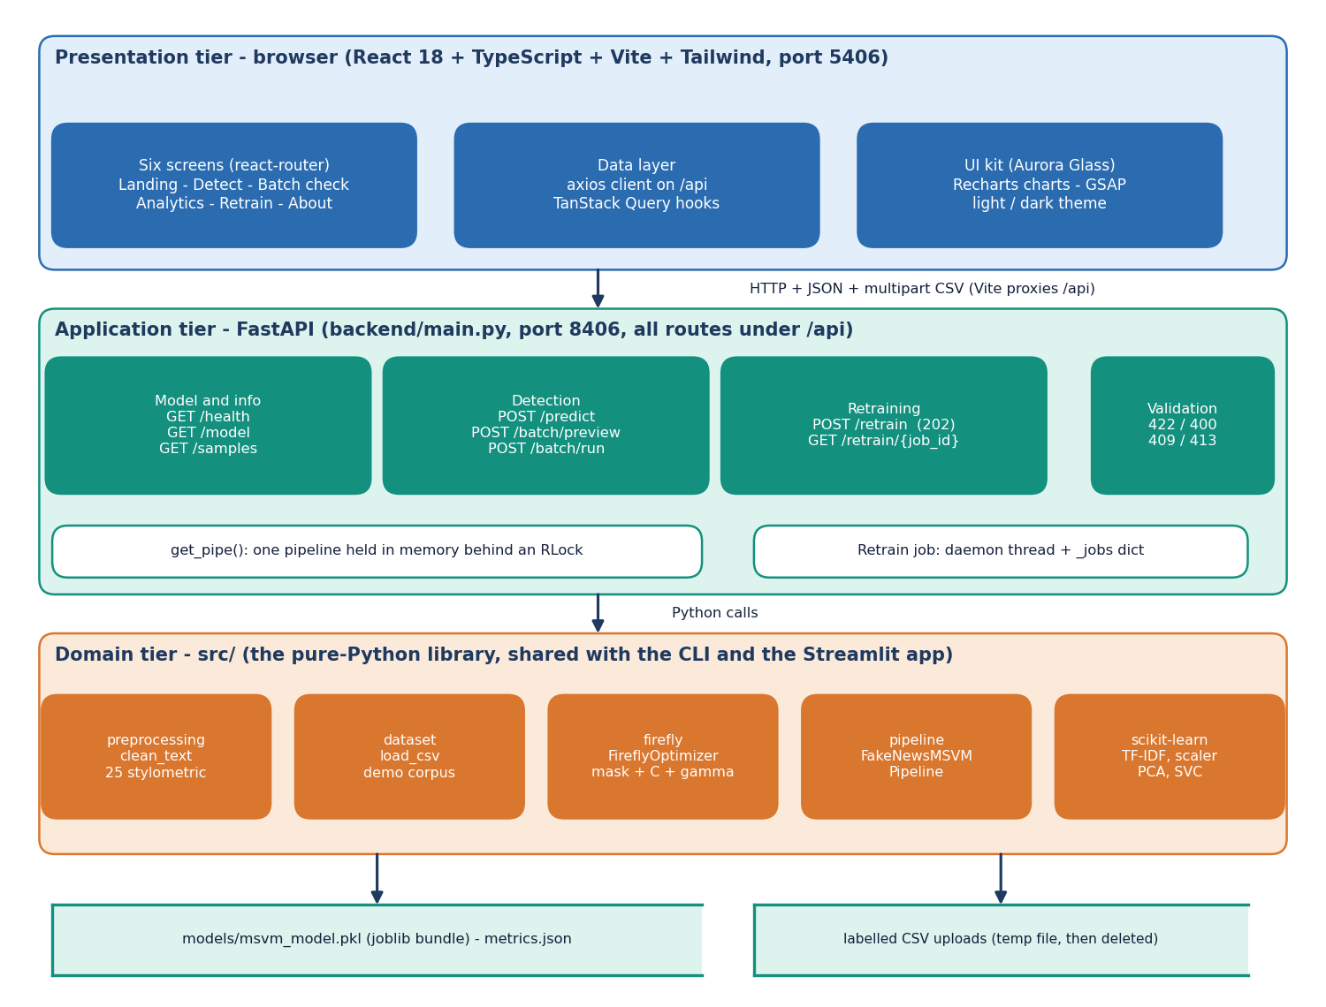
Figure 2: System architecture of TruthGlow: presentation, application and domain tiers over two file stores.
There are three tiers over two stores. The presentation tier is a React 18 and TypeScript application (Vite, Tailwind CSS, port 5406) with six screens and an axios client for /api. The application tier is a FastAPI service (backend/main.py, port 8406) with eight endpoints, one pipeline held in memory behind a re-entrant lock, and a background thread for retraining. The domain tier is the library src/ on scikit-learn. The stores are the joblib bundle models/msvm_model.pkl and the temporary file that holds an uploaded CSV while it is parsed. There is no SQL database and no user account. The Vite server proxies /api to port 8406 and the API also allows the two local origins on port 5406; both ports are set in .env.

5.3 High-Level Workflow
Figure 3: High-level workflow: the training path (offline or from the Retrain screen) and the inference path.
The training path cleans labelled text, builds TF-IDF and 25 stylometric features, standardises and reduces them with PCA, splits 80/20, lets the Firefly algorithm choose a subset of components with C and gamma, fits the RBF multi-class SVM with balanced class weights, evaluates and saves the bundle. The inference path applies the same fitted objects, keeps the selected components and asks the SVM for a class and probabilities.

5.4 Data Flow Diagrams
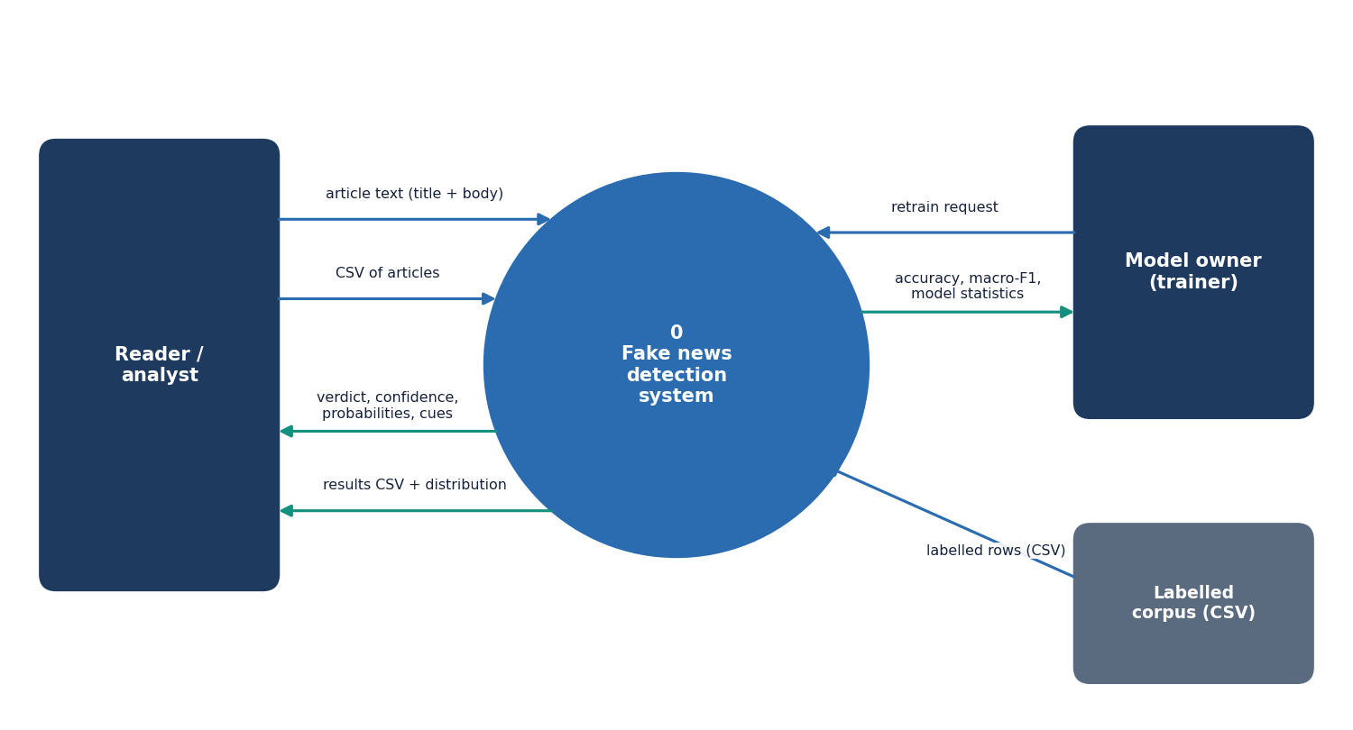
Figure 4: Level 0 data flow diagram: the system as one process with three external entities.
Level 0. The reader or analyst sends article text or a CSV and receives verdicts and results; the model owner sends a retrain request and receives accuracy, macro-F1 and statistics; a labelled CSV supplies training rows.
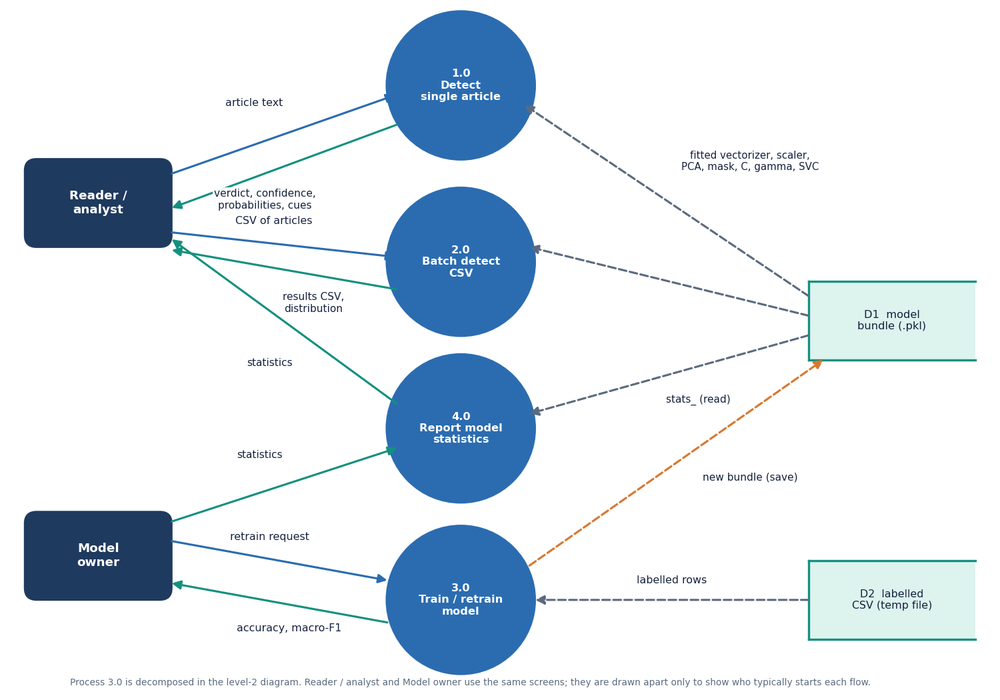
Figure 5: Level 1 data flow diagram: four processes and two data stores.
Level 1. Four processes: 1.0 Detect single article, 2.0 Batch detect CSV (both read the model bundle D1), 3.0 Train / retrain model (reads the temporary labelled CSV D2, writes D1) and 4.0 Report model statistics (reads the statistics inside D1).
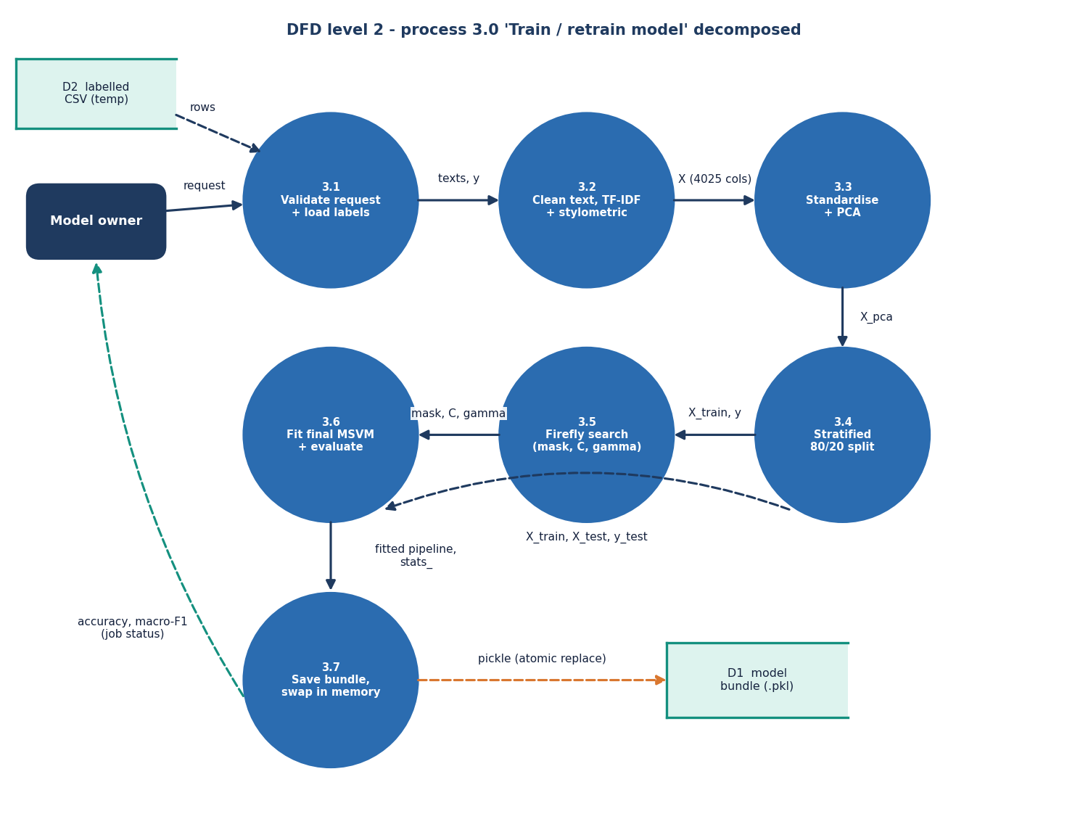
Figure 6: Level 2 data flow diagram: the seven steps inside process 3.0, Train / retrain model.
Level 2. Process 3.0 follows fit: 3.1 validate and load labels, 3.2 clean and featurise (4,025 columns), 3.3 standardise and PCA, 3.4 stratified 80/20 split, 3.5 Firefly search, 3.6 fit the final SVM and evaluate, 3.7 save the bundle, swap the in-memory pipeline under the lock and report the accuracy and macro-F1 as job status.

5.5 UML Diagrams
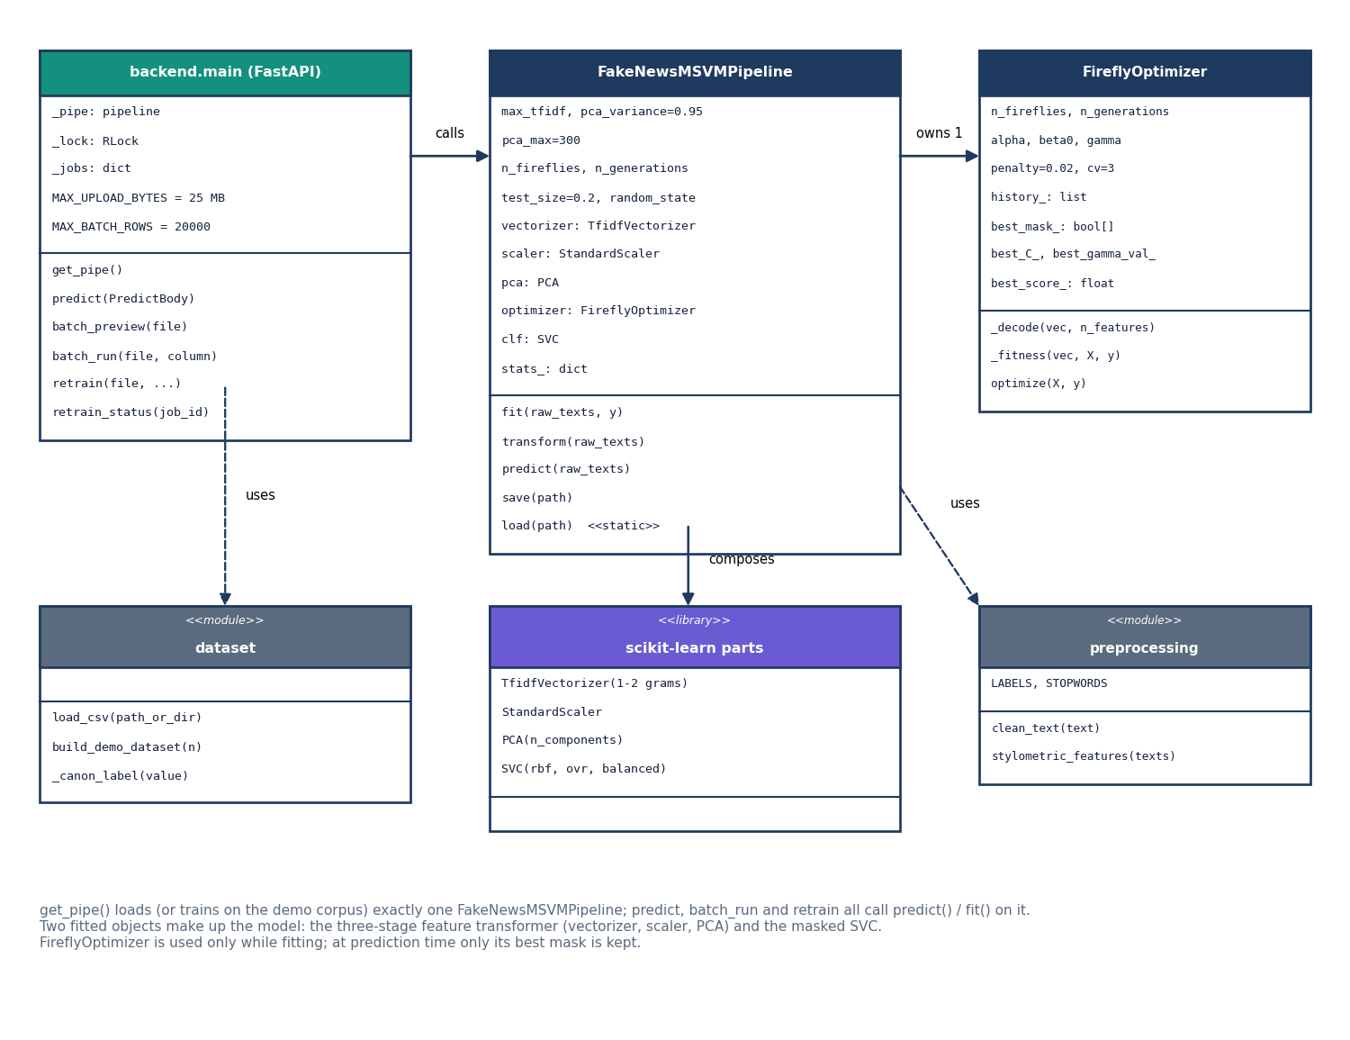
Figure 7: UML class diagram of the main classes and modules.
Class diagram. backend.main holds _pipe, _lock and _jobs and calls get_pipe(), which returns the one FakeNewsMSVMPipeline. The pipeline owns one FireflyOptimizer, composes the four scikit-learn parts and uses the preprocessing module; the backend uses the dataset module. The optimiser is needed only while fitting; at prediction time only its best mask, C and gamma are kept.
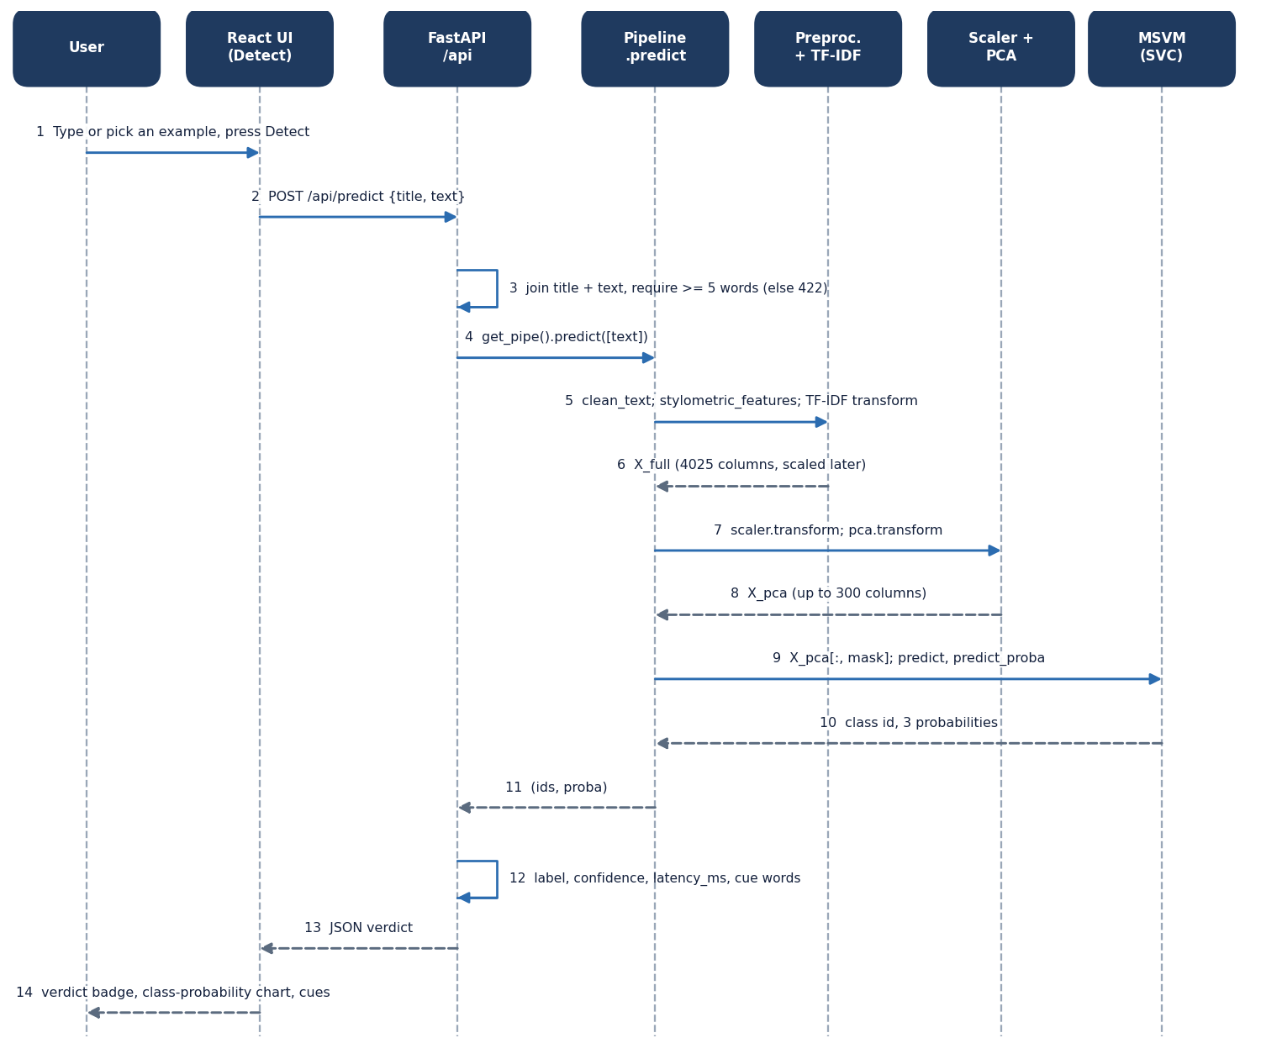
Figure 8: Sequence diagram of one detection request, from the Detect screen to the SVM and back.
Sequence: one detection. The page posts {title, text} to /api/predict; the backend rejects fewer than five words (422), asks the pipeline to predict, which cleans, featurises, scales, projects, masks and queries the SVM; the backend adds the confidence (largest probability), latency and cue words. Measured on the development machine: 3.7 ms mean inside the server and a median of 6.5 ms for the HTTP round trip.
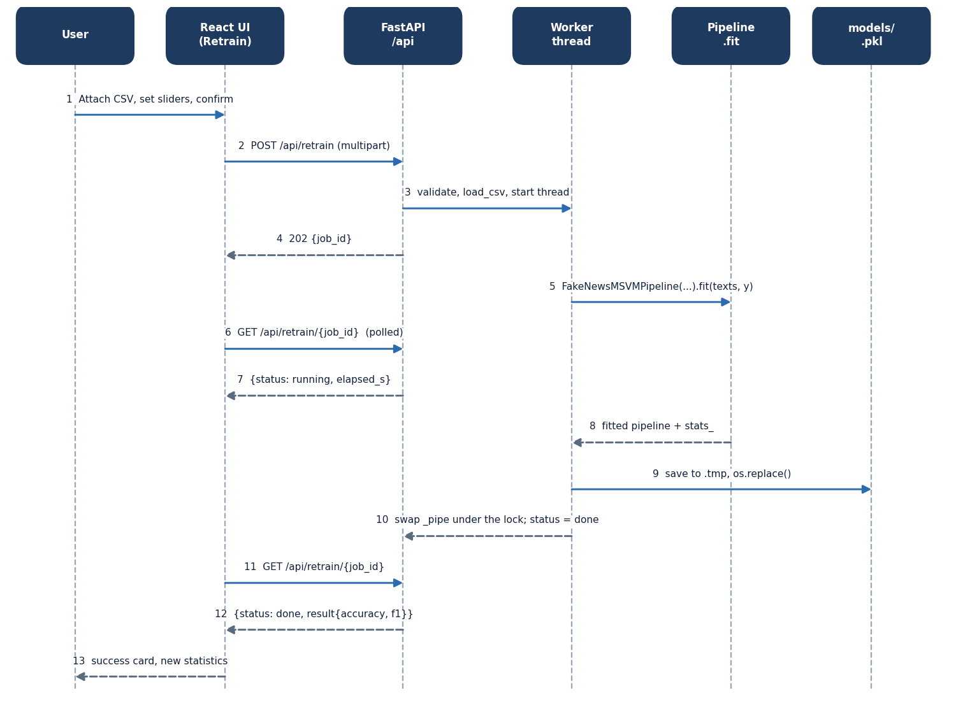
Figure 9: Sequence diagram of retraining: upload, background job, polling and hot swap.
Sequence: retraining. /api/retrain validates the request, starts a daemon thread and answers 202 with a job id; the page polls every two seconds (the id is kept in local storage so a reload resumes). The thread fits a new pipeline, saves it to a .tmp file, renames it over the model file, swaps the in-memory pipeline under the lock and marks the job done. On failure the previous model stays in use.
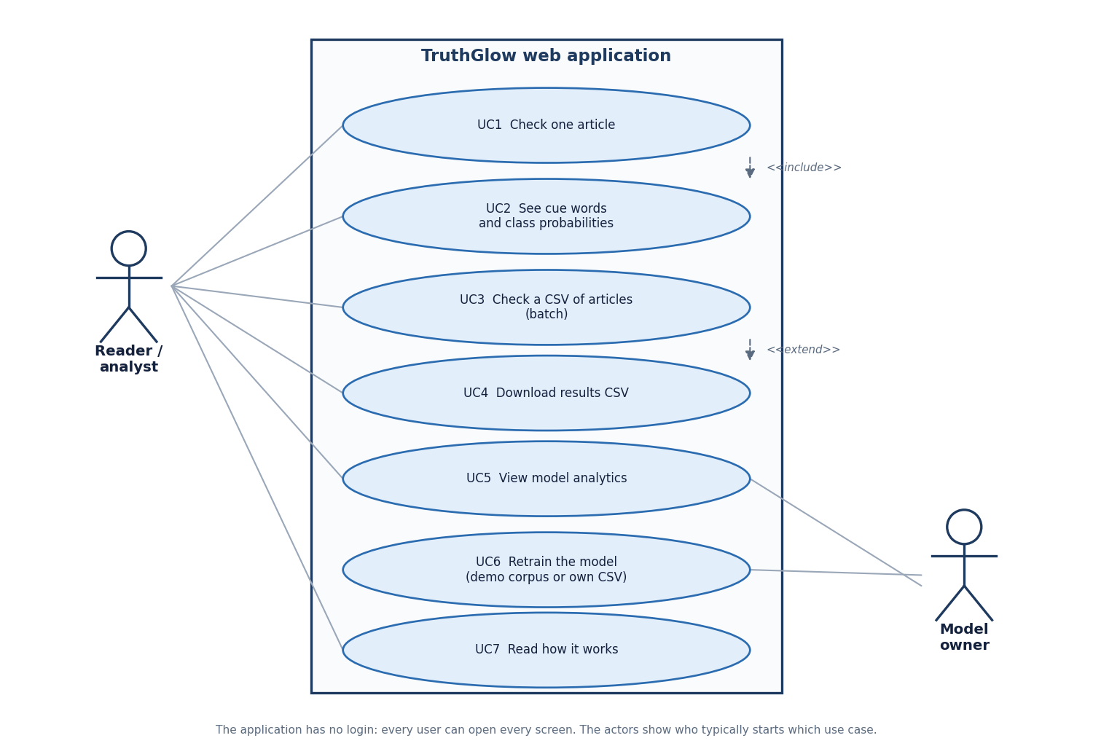
Figure 10: Use case diagram: seven use cases and two actors.
Use cases. The reader checks one article (UC1, including cues and probabilities UC2), checks a CSV (UC3, with download UC4), views analytics (UC5) and reads how it works (UC7); the model owner retrains (UC6) and views analytics. There is no login.

5.6 Data Design
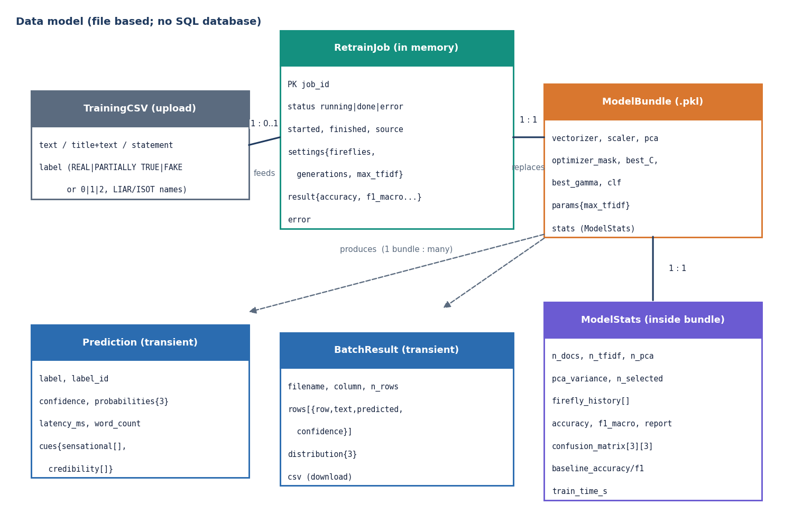
Figure 11: Entity-relationship diagram of the data model; the product has no SQL database.
The product has no SQL database because it keeps no records; the diagram shows the file and in-memory data model. A TrainingCSV feeds at most one RetrainJob (in memory, 12-character id); a finished job replaces the single ModelBundle, which contains its ModelStats; one bundle produces many Predictions and BatchResults, which are never stored.
Table 13: Persistent and transient data
Item | Where | Lifetime and content
Model bundle | models/msvm_model.pkl (joblib dictionary) | Until the next retrain: vectorizer, scaler, pca, optimizer_mask, best_C, best_gamma, clf, stats, params
Model statistics | Inside the bundle | n_docs, feature counts, n_pca, pca_variance, n_selected, firefly_history, accuracy, f1_macro, report, confusion_matrix, baseline scores, training time; y_test and y_pred are removed by /api/model
Retrain job | _jobs in the API process | Until restart: status, times, source, settings, result or error
Uploaded CSV | Temporary file | Deleted once parsed; text (or title + text, statement, news, content) and label

Two bundles exist: the shipped demo bundle (0.81 MB, 750 synthetic documents) and models/liar2_msvm_model.pkl (12.0 MB, trained on 3,000 real statements). Labels in a CSV may be REAL, PARTIALLY TRUE, FAKE, the numbers 0, 1, 2, or LIAR names (true and mostly-true become REAL, half-true PARTIALLY TRUE, barely-true, false and pants-fire FAKE).

5.7 Algorithm Design
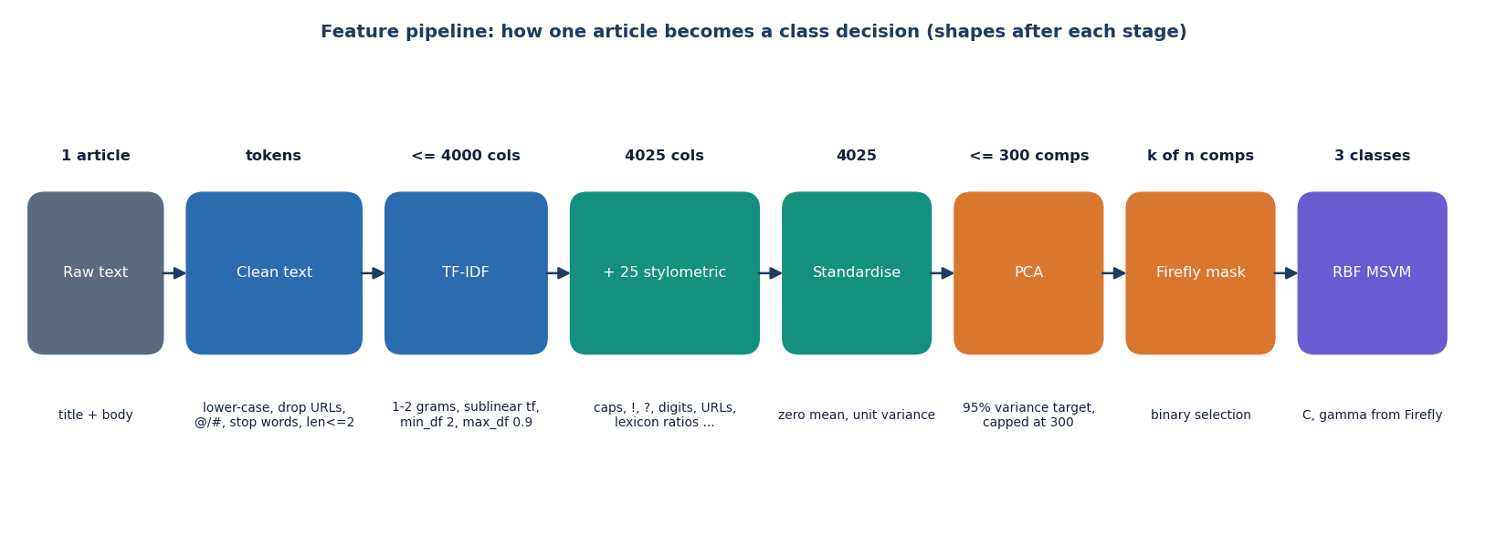
Figure 12: Feature pipeline: the shape of one article's representation after each stage.
One article becomes up to 4,000 TF-IDF values (1-2 grams, sublinear tf, min_df 2, max_df 0.9) joined to 25 stylometric values. After standardisation PCA keeps components for 95 % of the variance, capped at 300; the Firefly mask keeps a subset; the RBF SVM decides. On real statements the cap is always reached and keeps only 29.3% of the variance; on the demo corpus 95 % needs 136 components.
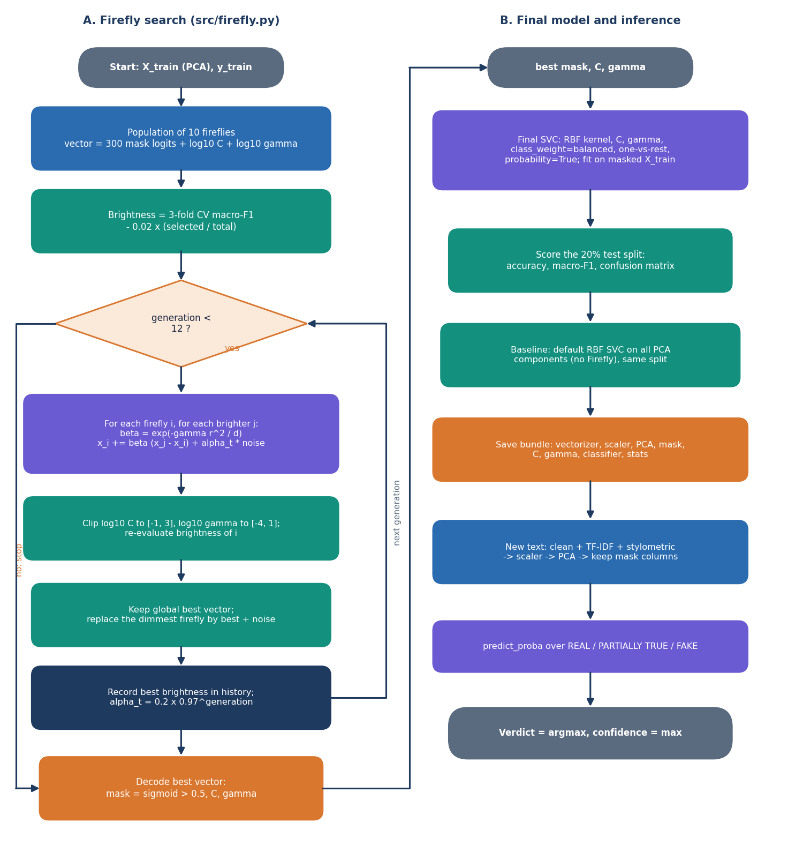
Figure 13: Flowchart of the core algorithm: (A) the Firefly search and (B) the final model and inference.
Encoding. A firefly has k + 2 entries: one logit per PCA component (kept when sigmoid exceeds 0.5; one is forced on if none is), log10 C in [-1, 3] and log10 gamma in [-4, 1]. Fitness. Mean macro-F1 of a three-fold stratified cross-validation of SVC(rbf, class_weight='balanced') on the masked data, minus 0.02 times the share of components kept; macro-F1 is used because FAKE is the largest class and accuracy would reward majority guessing. Movement. Attractiveness is beta0 exp(-gamma r^2 / length) with beta0 = gamma = 1; noise alpha starts at 0.2 and decays by 0.97 per generation; after each generation the dimmest firefly is replaced by the best vector plus noise. Ten fireflies and twelve generations are the defaults.

5.8 Module Design
Table 14: Modules and their responsibilities
Module | Lines | Main contents
src/preprocessing.py | 91 | clean_text; stylometric_features (25 values: lengths, ratios of unique, stop, capitalised, long and short words, punctuation, digits, URLs, first person, superlatives and three lexicon scores); LABELS
src/dataset.py | 110 | load_csv (file or folder; LIAR and ISOT layouts); build_demo_dataset (synthetic template corpus)
src/firefly.py | 106 | FireflyOptimizer: _decode, _fitness, optimize
src/pipeline.py | 181 | FakeNewsMSVMPipeline: fit, transform, predict, save, load; statistics and baseline
backend/main.py | 339 | Eight endpoints, get_pipe(), _cues() (13 sensational and 8 credibility words), _read_csv_upload(), one validation handler; status codes 422, 400, 413, 409, 404
frontend/src/pages/ | 1,303 | Landing, Detect, Batch, Analytics, Retrain, About, NotFound; each a lazily loaded chunk
frontend/src/components, lib | - | Aurora Glass kit (AppShell, Card, Button, Field, Slider, Table, FileDrop, Toast, charts, motion), api.ts, queries.ts, verdict.ts, theme.tsx

Server state is handled by TanStack Query: model information is cached for 60 seconds, the examples for the session, the API health is polled every 20 seconds and a retraining job every 2 seconds while it runs.

5.9 User Interface Design
The interface follows the Aurora Glass kit: translucent cards over a dark aurora background with a light theme remembered in the browser. The application screens share one shell: a collapsible sidebar (a drawer on narrow screens), a top bar with a live "Model online" indicator and the theme toggle. Colour is never the only signal: each verdict has its own icon and word, and every field has a label, hint and error sentence.
Table 15: Screens
Route | Screen | Main elements
/ | Landing | Hero with live demo verdict, technology strip, metric strip, how it works, feature cards
/app | Detect | Headline and text fields (five words needed, Ctrl+Enter), examples, verdict badge, confidence bar, probability chart, cue lists
/app/batch | Batch check | CSV drop zone, ten-row preview, column selector, summary cards, distribution chart, sortable table (first 50 rows), results download
/app/analytics | Model analytics | Stat cards, what the optimisation did, confusion matrix, Firefly curve, classification report, baseline against proposed
/app/retrain | Retrain | Optional labelled CSV, sliders (fireflies 4-20, generations 3-30, TF-IDF 1,000-8,000), confirm dialog, progress and success cards
/app/about | About | Pipeline steps, output classes, loaded model read live, how to run

  Figure 14: Detect screen with a real LIAR2 test statement entered. |   Figure 15: Retrain screen with a 600-row labelled CSV attached.

The results of each screen, produced by the model trained on real data, are shown and discussed in Chapter 8.

5.10 Design Decisions and Their Consequences
Table 16: Design decisions
Decision | Reason | Consequence
Thin API over the library | One code path for web, CLI and Streamlit | A fix in src/ reaches all front ends
One model in memory behind a lock | Prediction costs 3.7 ms; loading takes seconds | Retraining swaps the object under the lock
Everything in one joblib file | Keeps fitted parts consistent | 12.0 MB real-data bundle; needs the scikit-learn version that wrote it (1.9)
Retraining as a polled background thread | Training takes minutes; browsers time out | Job state is lost on restart; the page then reports an unknown job
Atomic replacement of the model file | A failed run leaves the previous model usable | Retraining overwrites the shipped model unless FAKENEWS_MODEL points elsewhere
PCA capped at 300 components | Bounds search space and SVM cost | Only 29.3% of the variance is kept on real text
Class weights and macro-F1 fitness | Real data is unbalanced | Accuracy falls below the majority-class rate (0.576) while macro-F1 rises
SVC(probability=True) for probabilities | Per-class probabilities with no extra code | Verdict and largest probability disagree on 48.8% of real test statements (found in testing)
No login or database | Local single-user tool; privacy by default | No audit trail; anyone who can reach the port can retrain
Results CSV returned in the batch response | Simple, nothing stored | Limit 20,000 rows and 25 MB; 2,296 rows took 1.2 s

The design favours a system that can be run, inspected and measured over a large one. The cost shows in the missing stemming step, the single-user assumption and the in-memory job table; none affects the correctness of a verdict, but each limits deployment.

CHAPTER 6: METHODOLOGY AND SOFTWARE IMPLEMENTATION

6.1 Overall methodology
The method is a classical supervised text-classification pipeline in which every stage is chosen to keep the model small and cheap to run on a CPU. A news statement is cleaned, turned into a sparse vector of word and word-pair weights (TF-IDF) and 25 hand-built stylistic measurements, standardised, compressed by Principal Component Analysis (PCA), and then classified by a multi-class Support Vector Machine (MSVM) with a radial-basis-function (RBF) kernel. The Firefly algorithm, a population-based metaheuristic, searches jointly for the subset of PCA components to keep and for the SVM parameters C and gamma [6, 7]. The classifier outputs one of three verdicts: REAL, PARTIALLY TRUE or FAKE, with a confidence. The steps are:
1. Assemble a labelled corpus of statements with a truthfulness label (LIAR2 for the real measurements, a synthetic template corpus for the shipped demo model).
2. Clean the text: lower-case, remove URLs, mentions and hashtags, keep letters only, drop stop words and tokens of two characters or fewer.
3. Featurise: TF-IDF over unigrams and bigrams (vocabulary capped at 4,000 terms in the experiments) plus 25 stylometric features, 4,025 columns in all.
4. Standardise every column and reduce with PCA (target 95 % of the variance, at most 300 components).
5. Split the reduced vectors 80/20 with a stratified split; the Firefly search sees only the 80 % part.
6. Optimise: the Firefly algorithm evolves a binary component mask and the values of C and gamma; a candidate's fitness is its 3-fold cross-validated macro-F1 minus a small penalty for the share of components kept.
7. Train and evaluate: fit the final RBF SVM with balanced class weights on the masked training part, score the 20 % hold-out, and fit a default-parameter SVM on all components as the baseline.
8. Save and serve: store the fitted vectoriser, scaler, PCA, mask, C, gamma, classifier and statistics in one .pkl bundle, used by the API, the command line and the Streamlit app.
Figure 16: Shape of the data after each stage of the feature pipeline.
Evaluation protocol for the real-data results. The pipeline code is the product's own (src/pipeline.py, unchanged). For LIAR2 a stratified subsample of 3,000 statements is drawn from the 18,369-statement training split, the pipeline is fitted on it, and the fitted model is scored on the complete official validation (2,297) and test (2,296) splits. This is repeated for 3 seeds (2024, 42, 7); results are reported as mean and standard deviation. Beside the proposed pipeline the same test split scores (i) the default-parameter SVM on the same PCA space, (ii) an SVM using only the Firefly mask with default C and gamma, (iii) an SVM tuned by random search with exactly as many fitness evaluations as the Firefly run used and the same fitness function, (iv) three linear or probabilistic models on plain TF-IDF (complement naive Bayes, logistic regression, linear SVM) trained on the same subsample and on the full training split, and (v) a majority-class predictor. The subsample size is a compute limit: a Firefly run needs about 550 cross-validated SVM fits.

6.2 Dataset

6.2.1 LIAR2: the dataset behind every real measurement
LIAR2 is a benchmark of about 23,000 short political statements checked by professional fact-checkers, released by Xu and Kechadi [4] as an extension of the LIAR dataset of Wang [5]. It was downloaded from the Hugging Face dataset chengxuphd/liar2 (licence Apache-2.0) and is not redistributed with the submission; data/liar2/ holds the downloaded CSV files. The official 8:1:1 split gives 18,369 training, 2,297 validation and 2,296 test statements, with an average of about 17.7 tokens per statement. Each statement carries one of six labels: pants-on-fire, false, barely-true, half-true, mostly-true, true. Only the statement text is used. The CSV also holds speaker, subject, justification and per-speaker historical counts of past ratings; these were deliberately left out because they leak the label (the justification is the fact-checker's verdict text, and the speaker counts record how often the same speaker was rated false) and would not exist for a new claim.
Table 17: Mapping from the six LIAR2 labels to the three classes of the product
LIAR2 label (id) | Project class | Statements in the whole dataset
true (5), mostly-true (4) | REAL | 2,585 + 3,429 = 6,014
half-true (3) | PARTIALLY TRUE | 3,709
barely-true (2), false (1), pants-on-fire (0) | FAKE | 3,603 + 6,605 + 3,031 = 13,239

The mapping follows the one coded in src/dataset.py for LIAR-style word labels (true and mostly-true are REAL, half-true is PARTIALLY TRUE, the rest FAKE). The experiment script applies the same rule to the numeric ids. The result is imbalanced: FAKE is the majority class. The test split holds 602 REAL, 371 PARTIALLY TRUE and 1323 FAKE statements, so a predictor that always answers FAKE is right 57.6 % of the time; the training subsample holds 786 / 484 / 1730. For this reason macro-F1, which weighs the three classes equally, is the headline metric and accuracy is always shown beside it.

6.2.2 The synthetic demo corpus
The repository also contains build_demo_dataset (src/dataset.py): a generator of a balanced three-class corpus from five sentence templates per class and ten topics, with a short phrase appended to about 30 % of the sentences. REAL templates read like official reports ("... confirmed by independent experts with verified data"), PARTIALLY TRUE templates mix a claim with doubt ("... but experts say evidence is partial"), and FAKE templates use clickbait words ("SHOCKING secret ... miracle ... click now"). The shipped model models/msvm_model.pkl was trained on 750 such documents (250 per class) with a hold-out of 150. Because the three classes differ in their template words alone, that model scores accuracy 1.000 and macro-F1 1.000 on its own hold-out (Firefly fitness 0.9916); it is a pipeline check and a way to run the application without a download. On the real LIAR2 test split the same model reaches accuracy 0.192 and macro-F1 0.155 and answers PARTIALLY TRUE for 2,044 of the 2,296 statements.
Table 18: The two data sources
 | LIAR2 (real) | Demo corpus (synthetic)
Source | Hugging Face chengxuphd/liar2, Apache-2.0 | build_demo_dataset, generated in code
Documents used to fit | 3,000 statements per run (subsample of 18,369) | 750 (250 per class)
Evaluation | Official test split, 2,296 statements; validation 2,297 | 20 % hold-out of the same templates, 150 documents
Class balance | Imbalanced: FAKE is 57.6 % of the test split | Balanced: 50 per class in the hold-out
What a high score means | Evidence about reading real claims | Only that the template words separate the classes

6.3 Preprocessing and feature construction

6.3.1 Text cleaning
clean_text (src/preprocessing.py) prepares text for the TF-IDF vectoriser. It lower-cases the text, replaces URLs (http://..., www...) and tokens that start with @ or # by a space, replaces line breaks and every character that is not an English letter by a space, collapses repeated spaces, splits on spaces and removes tokens that are stop words or have two characters or fewer. The stop-word list is a built-in set of 128 English function words, so no external download is needed. The function accepts any input: a non-string value returns an empty string. There is no stemming or lemmatisation; this differs from objective 2 of the project, which lists stemming, and is recorded as a deviation in Chapter 8. Because every non-letter is removed, digits and percentages ("58 percent", "9.4%") are discarded by the cleaner; they are still counted by the stylometric features, which read the raw text.

6.3.2 TF-IDF features
The cleaned text is vectorised with scikit-learn's TfidfVectorizer [14]: unigrams and bigrams, sublinear term frequency (1 + ln tf), terms must occur in at least two documents (min_df=2) and in at most 90 % of them (max_df=0.9), and the vocabulary is capped at max_features terms (4,000 in train.py, the Retrain screen and the experiments; 5,000 is the constructor default). Rows are L2-normalised. On the 3,000-statement training subsample the vocabulary reaches the cap, giving 4,000 TF-IDF columns [13].

6.3.3 The 25 stylometric features
stylometric_features computes 25 numbers per document from the raw (uncleaned) text. They describe style rather than topic: length, punctuation, capitalisation, digits, lexical variety and the density of words from three small built-in lexicons. Style cues are a recognised, if weak, signal of veracity and hyperpartisanship [21, 22, 20].
Table 19: The 25 stylometric features, in column order
# | Feature | Definition
1 | chars | Number of characters of the text
2 | n_words | Number of whitespace-separated words (at least 1)
3 | n_sent | Number of segments when splitting on . ! ? (at least 1)
4 | avg_wlen | Mean word length in characters
5 | uniq_ratio | Distinct words divided by words
6 | stop_ratio | Share of words that are stop words
7 | pos | Share of words from the positive lexicon (true, great, excellent, verified, confirmed, official, evidence, proven, real, accurate, trust)
8 | neg | Share of words from the negative lexicon (shocking, secret, unbelievable, miracle, hoax, conspiracy, exposed, urgent, breaking, viral, click, banned, hidden)
9 | sens | Share of words from the sensational lexicon (11 entries; "you wont believe" is a three-word entry that a single-token match can never hit)
10 | caps_ratio | All-capital words (two letters or more) divided by words
11 | upper | Count of all-capital words
12 | exclaim | Number of exclamation marks
13 | question | Number of question marks
14 | punct_ratio | Punctuation characters divided by characters
15 | words_per_sent | Words divided by sentences
16 | long_word_ratio | Share of words longer than 6 characters
17 | short_word_ratio | Share of words of 3 characters or fewer
18 | digit_ratio | Digits divided by characters
19 | exclaim_flag | 1 if more than 2 exclamation marks, else 0
20 | question_flag | 1 if more than 1 question mark, else 0
21 | url_flag | 1 if the text contains a URL
22 | urls | Number of URLs
23 | first_person | Share of words in {i, we, us, our, my}
24 | superlative | Share of words longer than 5 characters ending in "est"
25 | neg_minus_pos | neg minus pos

The features have very different scales, which is why the next stage standardises every column. The 4,025 columns are stored densely (about 100 MB for 3,000 documents), one reason the pipeline suits only corpora of a few thousand documents.

6.4 Algorithm choice and justification
Table 20: Why each component was chosen, and what the measurements say
Component | Role | Why chosen | What was found
TF-IDF (1-2 grams) | Sparse word and word-pair weights | Cheap, needs no pre-trained model or GPU, standard strong baseline for text [13, 19]; bigrams catch short phrases | Linear models on TF-IDF alone reach macro-F1 0.500 ± 0.000 (logistic regression, full training split)
25 stylometric features | Style signals: caps, punctuation, lexicon density | Cheap and interpretable; the lexicons also drive the cue words shown in the interface | Not ablated separately; their individual contribution is not measured
StandardScaler | Zero mean, unit variance per column | PCA and RBF-SVM are scale sensitive; stylometric columns are on very different scales | Also gives rare TF-IDF terms the same variance as common ones, which spreads variance over many components
PCA | Dense low-dimensional representation | The task statement asks for dimensionality reduction; shrinks 4,025 columns before the SVM [10, 11] | Cap of 300 components keeps only 29.3% of the variance on real text, far below the 95 % target
Firefly algorithm | Joint search of component mask, C, gamma | Metaheuristic that handles a mixed binary and continuous search space without gradients [6, 7, 25, 24] | Fitness 0.4334 against 0.4256 for equal-budget random search, but no clear gain on the test split (Chapter 8)
RBF multi-class SVM | Final classifier | Margin classifier that works well with a few thousand dense, moderate-dimension samples [8, 9] | Test macro-F1 0.429 ± 0.010
Balanced class weights | Rescales the penalty C per class | FAKE is the majority class; weighting counteracts imbalance without resampling [15, 1] | Raises recall of the minority classes at the cost of accuracy: the weighted model scores accuracy below the 0.576 majority baseline but macro-F1 above it (0.244)
Platt scaling (probability=True) | Class probabilities for the interface | The interface shows a confidence and a probability per class [12] | Probabilities and verdict disagree on 48.8% of the real test statements (Section 6.6.3)

Why not a transformer. The base paper's strongest system uses contextual transformer embeddings with a neural network on a GPU, reaching accuracy 95.52 % on a binary Arabic task [1]; fine-tuned transformers also dominate the comparison of Dell'Oglio et al. [2]. The gap named by this project is the opposite end of the trade-off: a pipeline that a student laptop can train and run without a GPU, whose cost is dominated by a search that can be shortened or switched off. The measurements in Chapter 8 test whether that cheaper pipeline keeps enough accuracy; the honest answer on LIAR2 is that it does not beat even simpler linear models, so the choice is justified by cost and transparency, not by accuracy.

6.5 Mathematical formulation

6.5.1 TF-IDF
For term t in document d, with n documents and document frequency df(t), scikit-learn's smoothed, sublinear weight is
w(t, d) = (1 + ln tf(t, d)) · idf(t), idf(t) = ln((1 + n) / (1 + df(t))) + 1 (2)
and each document vector is scaled to unit Euclidean length. Standardisation of every column j of the concatenated matrix is
z(i, j) = (x(i, j) − μ_j) / σ_j (3)

6.5.2 PCA
Let Z be the standardised n × p matrix and λ_1 ≥ λ_2 ≥ ... the eigenvalues of its covariance matrix. The principal components are the corresponding eigenvectors and the projection keeps the first k components, where k is the smallest number whose explained-variance share reaches 0.95, then limited to the range 10 to 300 (and to n − 1):
k = min( max(10, min(k_95, 300, n − 1)), p ), k_95 = min{ k : (λ_1 + ... + λ_k) / (λ_1 + ... + λ_p) ≥ 0.95 } (4)
On the LIAR2 subsample k_95 is far larger than 300, so the cap decides: k = 300 in every run and the retained variance is 29.3% ± 0.2%.

6.5.3 SVM with RBF kernel and class weights
The kernel and the weighted soft-margin problem for a binary sub-problem are
K(x, x') = exp(−γ ‖x − x'‖²) (5)
min over w, b, ξ : ½ ‖w‖² + C · Σ_i c(y_i) · ξ_i subject to y_i (wᵀφ(x_i) + b) ≥ 1 − ξ_i, ξ_i ≥ 0 (6)
c(k) = n / (K · n_k) (class_weight = "balanced", K = 3 classes, n_k = documents of class k) (7)
scikit-learn's SVC handles three classes by training K(K − 1)/2 = 3 one-versus-one binary classifiers and predicting by voting; the option decision_function_shape="ovr" used here only reshapes the decision values into one score per class and does not change the predicted label. The project's "MSVM" is therefore this one-versus-one machine with a one-versus-rest view of its scores [9].

6.5.4 Firefly search
Each firefly i is a vector x_i of length d = n_c + 2, where n_c is the number of PCA components: n_c mask logits followed by log10 C and log10 gamma. It is decoded as
m_k = 1 if sigmoid(x_ik) > 0.5 else 0 ; C = 10^clip(x_i,n_c+1, −1, 3) ; γ = 10^clip(x_i,n_c+2, −4, 1) (8)
(if no mask bit is set, the component with the largest logit is switched on). Brightness is the fitness: the mean macro-F1 of a stratified 3-fold cross-validation of the RBF SVM (balanced weights) on the masked training data, less a penalty on the size of the subset; a mask with fewer than two components scores 0:
f(x_i) = F1_macro^(3-fold)(m, C, γ) − 0.02 · |m| / n_c (9)
A less bright firefly i moves toward each brighter firefly j. The attractiveness decays with the squared distance r², normalised by the dimension, and a random step shrinks every generation g:
β = β_0 · exp(−γ_f · r_ij² / d) , r_ij² = ‖x_i − x_j‖² , α_g = α_0 · 0.97^g (10)
x_i ← x_i + β (x_j − x_i) + α_g · 2(u − ½) , u ~ Uniform(0, 1)^d (11)
with β_0 = 1, γ_f = 1 and α_0 = 0.2 (the absorption coefficient γ_f is the algorithm's own and is unrelated to the SVM's gamma). After each move the two hyper-parameter coordinates are clipped to their ranges and the firefly's brightness is recomputed, so every move costs one cross-validation. At the end of each generation the best vector so far is remembered and the dimmest firefly is replaced by that vector plus a small random step (elitism). The initial population is uniform in [−1, 1] for the mask logits, [−1, 2] for log10 C and [−3, 0] for log10 gamma. With 10 fireflies and 12 generations a run made seed 2024: 571, seed 42: 511, seed 7: 567 fitness evaluations.
Figure 17: Flowchart of the Firefly search and of the final model.

6.5.5 Metrics and Platt scaling
P_k = TP_k / (TP_k + FP_k) , R_k = TP_k / (TP_k + FN_k) , F1_k = 2 P_k R_k / (P_k + R_k) , macro-F1 = (F1_1 + F1_2 + F1_3) / 3 (12)
Macro-F1 gives the small PARTIALLY TRUE class the same weight as FAKE. The class probabilities shown in the interface come from Platt scaling: libsvm fits a sigmoid to the decision values by an internal 5-fold cross-validation and couples the pairwise results into three probabilities,
P(y = 1 | f) = 1 / (1 + exp(A f + B)) (13)
The sigmoid is fitted on the original class frequencies, whereas the class-weighted decision function that produces the verdict is not; this is the origin of the disagreement documented in Section 6.6.3.

6.6 Model architecture and training configuration

6.6.1 Architecture of the trained model
The trained model is the chain vectoriser, scaler, PCA, mask, SVM. FakeNewsMSVMPipeline.save writes all of these, with the best mask, C, gamma and the statistics of the run, into one joblib file. load rebuilds the pipeline from the file, so the Firefly optimiser exists at prediction time only as its best mask. The data shrinks as in the figure below: 4,025 columns, 300 PCA components and 148 ± 12 selected components.
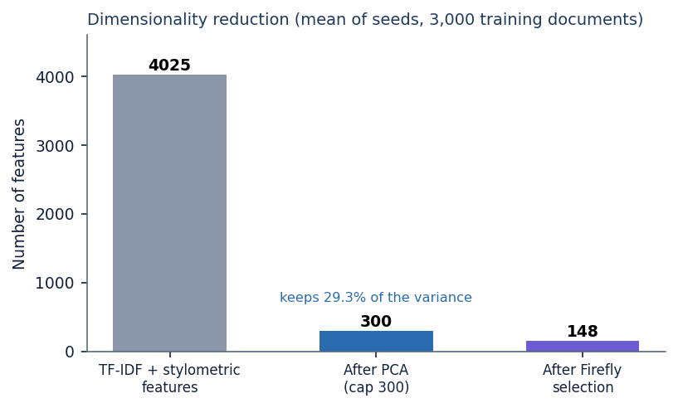
Figure 18: Feature counts after each stage (mean of three runs).
Table 21: Training configuration
Item | Setting
TF-IDF | ngram (1, 2), sublinear tf, min_df 2, max_df 0.9, max_features 4,000 (class default 5,000)
Stylometric features | 25 columns, concatenated: 4,025 in total
Scaling | StandardScaler, fitted on all training documents
PCA | 95 % variance target, at least 10 and at most 300 components (pca_max), random_state 42
Split | 80 / 20 stratified (test_size 0.2, random_state 42) of the PCA vectors
Firefly | 10 fireflies, 12 generations in train.py, the Retrain screen and the experiments (class defaults 12 and 15); α_0 0.2, β_0 1, γ_f 1, penalty 0.02, 3-fold CV, decay 0.97
SVM | kernel rbf, class_weight balanced, decision_function_shape ovr, probability True, random_state 42; C and gamma from the Firefly search
Baseline | SVC(class_weight="balanced") with default C = 1 and gamma = "scale" on all PCA components
Experiments | 3,000-statement stratified subsample, seeds 2024, 42, 7
Hardware | Intel Core i5-12500 (6 cores, 12 threads, 3.0 GHz), 15.7 GB RAM, Windows 11 Pro, no GPU used
Software | Python 3.11.9, scikit-learn 1.9.1, NumPy 2.4.6, SciPy 1.17.1, pandas 3.0.6, FastAPI 0.159.1, uvicorn 0.54.0, Node 24.19.0, React 18.3, Vite 8, TypeScript 5.9, Tailwind CSS 4

The vectoriser, scaler and PCA are fitted on all documents given to fit, including the 20 % held out inside the pipeline. This uses no labels, but it makes the internal hold-out score (shown on the Analytics screen) slightly optimistic; Chapter 8 therefore reports scores on the separate official test split. The final SVM is trained on the 80 % part only (2,400 of 3,000 statements).

6.6.2 What the search found
Table 22: Firefly results per run (10 fireflies, 12 generations)
Seed | Components kept (of 300) | C | gamma | Best fitness (CV) | Search + fit time (s)
2024 | 156 | 1.13 | 0.00094 | 0.4380 | 481
42 | 154 | 21.36 | 0.00061 | 0.4217 | 444
7 | 134 | 2.92 | 0.00152 | 0.4406 | 589

The three runs choose very different values of C (1.1 to 21.4) and about half of the components, which already suggests that the fitness surface is flat: many settings are almost equally good. the figure below shows the best fitness found in each generation. Most of the improvement comes in the first four generations. The search costs 504 ± 75 s per run, against 1.2 s for one default SVM fit; an equal-budget random search needs 480 s.
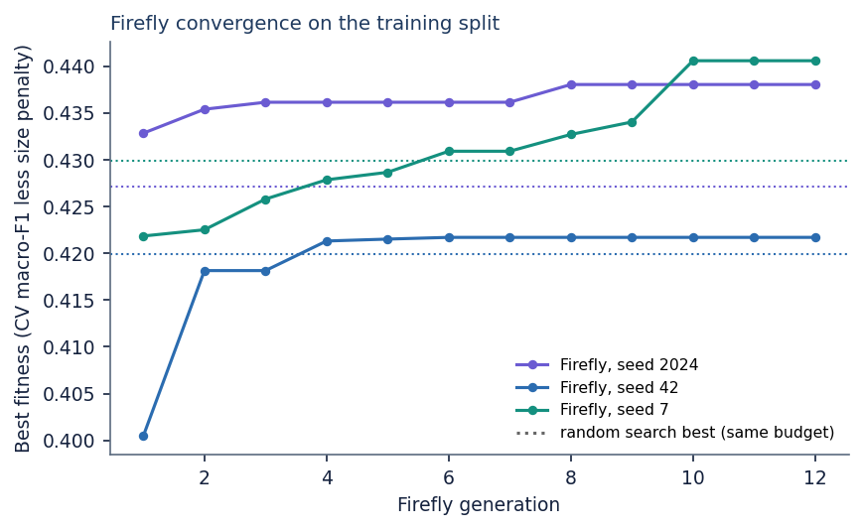
Figure 19: Best fitness per generation for the three runs; dotted lines mark the best fitness of the equal-budget random search of the same run.

6.6.3 Verdict and probabilities
predict returns two things: the class from SVC.predict, which uses the class-weighted decision function, and predict_proba, the Platt-scaled probabilities. The Detect screen displays the class as the verdict and the largest probability as the confidence. On real data the two differ: on 1,120 of 2,296 test statements (48.8%) the verdict is not the class with the highest probability, the probabilities name FAKE as the top class for 2,252 statements, and PARTIALLY TRUE is never the top-probability class (it is the verdict for 419 statements). Using the largest probability as the verdict would give accuracy 0.578 but macro-F1 only 0.264, because it almost always answers FAKE. The behaviour is documented as a limitation; no change was made to the code.

6.7 Application architecture
The product has a three-tier structure and keeps every earlier entry point working. The library src/ (preprocessing 91 lines, dataset 110, Firefly 106, pipeline 181) contains all model logic and has no web dependency. The API layer backend/main.py (339 lines, FastAPI) is a thin wrapper: every endpoint calls the same pipeline functions that the command line and the Streamlit app call, and no model logic lives in it. The web interface frontend/ (React 18, TypeScript, Vite, Tailwind CSS; about 4,900 lines, of which the six page components are 1,300) talks to the API through one axios client on /api, proxied by the Vite server so no port is hard-coded in the browser code. The older entry points train.py, predict.py and app.py (Streamlit) remain and use the same model file.
Table 23: Main files
File or folder | Role
src/preprocessing.py | clean_text, stylometric_features, stop words, class labels
src/dataset.py | load_csv (CSV, ISOT and LIAR layouts), build_demo_dataset
src/firefly.py | FireflyOptimizer: decode, fitness, optimise
src/pipeline.py | FakeNewsMSVMPipeline: fit, transform, predict, save, load
backend/main.py | FastAPI application, endpoints, validation, retraining job
frontend/src/pages/ | Landing, Detect, Batch, Analytics, Retrain, About, NotFound
models/ | msvm_model.pkl (demo model), liar2_msvm_model.pkl, metrics.json
scripts/, run.bat | Tests, experiments, measurement and document builders; one-click launcher (ports 8406 and 5406)

Model state. The API holds exactly one fitted pipeline in memory (get_pipe), protected by a re-entrant lock. It is loaded from the path in the environment variable FAKENEWS_MODEL (default models/msvm_model.pkl) when the server starts; if the file does not exist the server trains a small demo model on the synthetic corpus (250 documents per class, 8 fireflies, 8 generations) and saves it. Loading takes 6.1 s for the 12.6 MB LIAR2 model and 2.8 s for the 0.85 MB demo model, measured from process start to the first successful health check.
Retraining. POST /api/retrain validates the request, reads the optional CSV into texts and labels, creates a job record and starts a daemon thread that fits a new pipeline, writes it to a temporary file and replaces the model file with os.replace, then swaps the in-memory pipeline under the lock. The browser polls GET /api/retrain/{job_id} every 2 seconds. Only one job may run at a time. While training runs, /api/predict keeps using the old model, so detection never stops.

6.8 API design
All routes are under /api and exchange JSON (uploads use multipart form data). The interactive OpenAPI documentation is served at /docs by FastAPI.
Table 24: Endpoints
Method and path | Request | Response | Errors
GET /api/health | - | status, model_loaded, model_path | -
GET /api/model | - | labels, stats (accuracy, macro-F1, PCA and Firefly facts, confusion matrix, report, baseline; the raw test predictions are removed), pipeline steps | -
GET /api/samples | - | Six real documents from the demo corpus, two per class | -
POST /api/predict | JSON {title, text} | label, label_id, confidence, probabilities, latency_ms, word_count, cues{sensational, credibility} | 422 if fewer than 5 words
POST /api/batch/preview | multipart file (.csv) | filename, n_rows, columns, guessed_column, first 10 rows | 400 not a CSV, empty, unreadable; 413 over 25 MB
POST /api/batch/run | multipart file, column | n_rows, seconds, rows[{row, text, predicted, confidence}], distribution, csv | 400 bad column; 413 over 20,000 rows or 25 MB
POST /api/retrain | multipart optional file, fireflies, generations, max_tfidf | 202 {job_id} | 422 out of range; 400 bad CSV or under 30 rows; 409 a job is running
GET /api/retrain/{job_id} | - | status running / done / error, elapsed_s, source, settings, result or error | 404 unknown job (also after a restart)

The cue words returned by /api/predict come from two fixed lists in the backend: 13 sensational words (shocking, secret, unbelievable, miracle, hoax, conspiracy, exposed, urgent, breaking, viral, click, banned, hidden) and 8 credibility words (official, confirmed, verified, evidence, report, data, expert, audit). They only illustrate the verdict, and on real statements they rarely match.

6.9 Security and error handling
The application is a local tool without accounts, so security work is limited to input validation and safe handling of files. What exists, and what does not, is stated below.
Table 25: Validation and safety measures
Concern | Measure
Upload type, size and rows | More than 20,000 rows or 25 MB gives 413; only .csv names accepted; empty or unreadable files are rejected with 400
Free-text input | A statement needs at least five words (title and text joined) or the API answers 422; the browser shows the same rule before sending
Parameter ranges | Fireflies 4-20, generations 3-30, max TF-IDF 1,000-8,000; otherwise 422
Concurrent retraining | A second retraining request while one runs gets 409; the job store is a dictionary guarded by the single-job rule
Uploaded training data | Written to a temporary file that is deleted in a finally block after parsing; fewer than 30 rows or an unknown label column gives 400
Model file integrity | A new model is written to <model>.tmp and moved into place with os.replace, so a crash cannot leave a half-written model; the live pipeline is swapped under a lock
Cross-origin access | CORS allows only http://localhost:5406 and http://127.0.0.1:5406
Output encoding | The React interface renders text through JSX, which escapes HTML; a test confirms that script tags in an article do not break /api/predict
Privacy | Rows are read by the local backend only and are not stored

Not implemented: authentication, authorisation, rate limiting, HTTPS, audit logging, and any protection of the model file against replacement by the Retrain screen (it overwrites the file by design, and the interface asks for confirmation first). Pickle files can execute code when loaded, so a model file must come from a trusted source; loading a model pickled with a different scikit-learn version may fail, so run.bat installs the version the shipped model needs. These gaps are acceptable for a local demonstration and would have to be closed before any multi-user deployment.

6.10 Installation and execution
The measurements were made on: Intel Core i5-12500 (6 cores, 12 threads, 3.0 GHz), 15.7 GB RAM, Windows 11 Pro, no GPU used. Python 3.11 or newer and Node.js 20 or newer are required.

6.10.1 One-click start
1. Double-click run.bat. It checks that Python and Node.js are installed.
2. It builds .venv (and rebuilds it if a copy from another computer does not run) and installs backend/requirements.txt (scikit-learn, pandas, NumPy, SciPy, joblib, FastAPI, uvicorn, python-multipart).
3. It runs npm install in frontend/ on the first start.
4. It starts the backend on port 8406, waits until /api/health answers, then starts the frontend on port 5406 and opens http://localhost:5406.
5. Closing the two minimised windows stops the servers.

6.10.2 By hand
python -m venv .venv
.venv\Scripts\python -m pip install -r backend/requirements.txt
.venv\Scripts\python -m uvicorn backend.main:app --port 8406

cd frontend
npm install
npm run dev # http://localhost:5406

6.10.3 Command line, Streamlit and checks
python train.py # demo corpus, writes models/msvm_model.pkl and metrics.json
python train.py --csv data/my.csv --fireflies 10 --generations 12 --max-tfidf 4000
python predict.py --text "Official report confirmed by experts with verified data"
streamlit run app.py # the original interface

python scripts/smoke_test.py # API end to end on a copy of the model
python scripts/unit_edge_tests.py # library and edge-case tests
cd frontend && npm run build # type-check and production build

A training CSV needs a text column (and optionally title) and a label column holding REAL, PARTIALLY TRUE, FAKE, the numbers 0, 1, 2, or LIAR's word labels. Numeric six-way LIAR2 ids must be converted to the three class names first, because load_csv reads the numbers 0, 1 and 2 as the project's classes directly. Retraining from the Retrain screen replaces models/msvm_model.pkl; keep a copy to return to the shipped model. To reproduce the real-data results: download the three LIAR2 CSV files into data/liar2/, run scripts/run_experiments.py --seed 42 (and 7, 2024) with the project's Python, then scripts/docs_build/make_figures.py.

CHAPTER 7: SYSTEM TESTING

7.1 Testing strategy
Testing covers four layers. The small functions of the library (cleaning, features, label mapping, the Firefly decoder and fitness, the pipeline and its save/load round trip) are tested in isolation. The API is tested end to end against a real server started on a spare port with a copy of the model, so that the Retrain endpoint can never overwrite the shipped model. Edge cases and invalid inputs are driven through the same server. Finally the interface is built (type-check and production bundle) and every screen was exercised in a browser while the documentation screenshots were captured. All automated tests are in scripts/ and re-run with one command each. They test behaviour, not predictive quality: predictive quality is measured on held-out data and reported in Chapter 8. Before this documentation work the repository had one automated test script (smoke_test.py); unit_edge_tests.py was added, bringing the total to 83 automated checks, all of which pass.
Table 26: Test layers and results
Layer | What it covers | Script | Result
Unit: library | Text cleaning, stylometric features, label mapping, demo corpus, CSV loading, Firefly, pipeline | scripts/unit_edge_tests.py (in-process) | 34 of 34 passed
Integration: API | All eight endpoints, validation errors, batch run, a real retraining job | scripts/smoke_test.py (own server, port 8496) | 16 of 16 passed
Edge cases and validation | Boundaries of the 5-word rule, malformed and oversized uploads, parameter ranges, hostile or unusual text | scripts/unit_edge_tests.py (own server, port 8497) | 33 of 33 passed
Build | TypeScript type-check and Vite production build of the interface | npm run build | Passes (6.7 s)
Functional walk-through | All six screens used with real data (Section 7.4) | scripts/capture_docs_screens.py | All screens completed; 17 screenshots
Performance | Latency, batch throughput, training cost | scripts/measure_api.py, scripts/run_experiments.py | Section 7.6

7.2 Unit testing of the library
The in-process part of unit_edge_tests.py contains 34 checks. They use small synthetic inputs, a 90-point toy dataset for the optimiser and the 120-document demo corpus for the pipeline, so the whole group runs in under a minute.
Table 27: Unit checks by area
Area | Checks | Examples of what is asserted
Text cleaning (clean_text) | 5 | Lower-casing and URL removal; stop words and short tokens dropped; None and numbers give an empty string; @user #tag removed; digit-only text gives nothing
Stylometric features | 4 | 25 columns per text; all values finite even for an empty text; the exclamation count of "SHOCKING news!!! click now?" is 3; the more-than-two-exclamations flag is set
Class labels | 1 | LABELS is exactly REAL, PARTIALLY TRUE, FAKE
Label conversion (_canon_label) | 3 | LIAR word labels map to 0 / 0 / 1 / 2 / 2 / 2; 0, 1, 2 and the project's names map to themselves; unknown labels go to FAKE
Demo corpus | 2 | 60 documents, 20 per class, for n_per_class=20; two calls with the same seed return the same corpus
CSV loading (load_csv) | 6 | Title and text are joined; labels converted; the LIAR statement layout; a file without a label column raises ValueError; a missing path and a folder without CSV files raise
Firefly optimiser | 6 | Decoding never gives an empty mask; log C and log gamma are clipped to 3 and -4; fitness is 0 for fewer than two components; optimize returns a mask and positive C and gamma; one history entry per generation; the informative column is kept
Pipeline | 7 | Fit reports statistics; PCA stays between 10 and 300 components; at least one component selected; one id and three probabilities per text; probabilities sum to 1; an empty string is accepted; save and load give identical predictions

The Firefly tests assert properties that hold for every run (shapes, ranges, history length) and one that follows from a constructed dataset, not exact parameter values.

7.3 Integration testing of the API
scripts/smoke_test.py starts its own server on port 8496 with a copy of the model, waits for the health check and then calls every endpoint. Its 16 checks are:
Table 28: Smoke-test checks
# | Check | Expected
1 | Health | 200 and model_loaded true
2 | Model statistics | Three labels; accuracy present; raw test predictions absent
3 | Samples | All three classes represented
4 | Predict, sourced-style text | REAL with a confidence in (0, 1] and probabilities summing to 1
5 | Predict, clickbait text | FAKE and the cue word "shocking" found
6 | Predict, too short | 422 with a message naming the minimum
7 | Batch preview | Column text guessed; 3 rows
8 | Batch run | 3 rows scored; distribution sums to 3; results CSV has the added columns
9 | Batch, unknown column | 400
10 | Batch, non-CSV file | 400
11 | Retrain, fireflies out of range | 422
12 | Retrain accepted | 202 and a job id
13 | Second retrain while one runs | 409
14 | Retrain finishes | status done, accuracy above 0
15 | Predict after retraining | 200 on the new model
16 | Unknown job id | 404

Check 14 runs a complete retraining job (4 fireflies, 3 generations, 2,000 TF-IDF features), exercising the background thread, the atomic file replacement and the in-memory swap on a copy of the model.

7.4 Functional testing
The functional walk-through follows the use cases of Chapter 5 with real data. The screenshots in Chapter 8 are the record of this run: the interface was driven in Google Chrome by a Playwright script against the backend serving the LIAR2 model, at 1440 x 900 pixels in the dark theme.
Table 29: Functional scenarios
Use case | Scenario | Observed result
UC1 Check one article | Real LIAR2 test statement (a FAKE one about a shirt photo) typed into Detect | Verdict FAKE, confidence 83.8 %, class-probability bars, "None found" for both cue boxes (26 ms)
UC1 | A REAL statement about poverty among the elderly | Verdict REAL, confidence 54.1 %
UC1 | A PARTIALLY TRUE statement about unemployment | Verdict PARTIALLY TRUE shown with confidence 47.2 % while the FAKE bar is the tallest: the verdict/probability mismatch of Section 6.6.3
UC1 | A FAKE statement about the Declaration of Independence | Verdict REAL, confidence 53.4 %: a wrong answer, kept as the failure example
UC3 and UC4 Batch check | 120 real test statements (40 per class) uploaded as CSV, text column statement | Preview of the file, then 120 rows scored in 1.51 s as shown by the browser: 44 REAL, 24 PARTIALLY TRUE, 52 FAKE; results table and CSV download offered
UC5 Model analytics | Open the screen with the LIAR2 model loaded | Accuracy 48.67 %, macro-F1 0.4134, features 4025 to 154, train time about 442 s, confusion matrix, Firefly curve, classification report, baseline-versus-proposed table
UC7 About | Open the screen | Pipeline, classes and the loaded model's figures read live from the API
UC6 Retrain | Upload a 600-row labelled CSV (200 per class), 4 fireflies, 3 generations, confirm | Progress card while running, then "Retrained successfully": 600 documents, PCA 300, 147 components kept, accuracy 42.50 %, macro-F1 0.4113

The walk-through found no crash. It made visible two behaviours recorded in Section 7.9: verdicts that contradict the probability bars, and fixed text that still describes the demo model.

7.5 Security, validation and edge-case testing
The second half of unit_edge_tests.py sends 33 deliberately awkward requests to a live server. Every one passes: the server answers with the intended status code and stays up for the next request.
Table 30: API edge-case checks
Area | Checks | Cases
Health and model info | 3 | Model path reported; unknown route gives 404; model info hides the raw test predictions
Predict: boundaries | 4 | 4 words gives 422; exactly 5 words gives 200; title and text together count towards the 5; whitespace only gives 422
Predict: malformed input | 2 | Empty JSON body gives 422; a number instead of text gives 422
Predict: unusual text | 4 | A 5,600-word article; HTML with a script tag; Devanagari text; digits only. Each returns a verdict instead of failing
Predict: output contract | 2 | Probabilities cover exactly the three labels; latency is reported
Batch preview | 5 | Empty file and header-only file give 400; garbage bytes do not crash the server; unknown columns fall back to the first; only 10 rows previewed
Batch run | 5 | Blank lines are skipped by the CSV reader; an empty cell is kept and scored; 20,001 rows give 413; a 26 MB file gives 413; a missing file gives 422
Retrain | 7 | Fireflies 21, generations 2, TF-IDF 999 and 8,001 give 422; fewer than 30 rows, a file without labels and a non-CSV upload give 400
Samples | 1 | Six examples, two per class

These checks cover input validation, size limits, hostile content and parameter bounds. They do not amount to a security audit: there is no authentication to test, no penetration test was run and the pickle-loading risk of Section 6.9 is accepted rather than tested.

7.6 Performance testing

7.6.1 Latency and throughput of the API
scripts/measure_api.py starts a backend for each model, measures the time to the first successful health check, then makes 300 sequential POST /api/predict calls (after 10 warm-up calls) with real LIAR2 test statements, and then three batch runs. It addresses 127.0.0.1 rather than localhost, because name resolution adds about two seconds per call on the test machine. The PC was idle. Hardware: Intel Core i5-12500 (6 cores, 12 threads, 3.0 GHz), 15.7 GB RAM, Windows 11 Pro, no GPU used.
Table 31: Single-article latency (milliseconds, 300 requests)
Model | Start-up (s) | Server mean | Server p50 | Server p95 | Client mean | Client p50 | Client p95 | Client max
LIAR2 model (12.6 MB) | 6.1 | 3.7 | 3.5 | 5.3 | 12.6 | 6.5 | 29.8 | 76.7
Demo model (0.85 MB) | 2.8 | 2.2 | 2.0 | 3.8 | 9.7 | 5.0 | 27.7 | 31.8

The server needs about 3.7 ms per article with the LIAR2 model and the browser sees about 6.5 ms at the median; the larger model costs about 1.5 ms more because its SVM has more support vectors. The slowest request took 77 ms, which is still well under the 0.1 s that users perceive as instant.
Table 32: Batch throughput (server time in seconds)
Model | 100 rows | 1,000 rows | 2,296 rows | ms per row (2,296)
LIAR2 model | 0.13 | 0.55 | 1.20 | 0.52
Demo model | 0.02 | 0.20 | 0.66 | 0.29

A whole test split of 2,296 statements is scored in about a second, so the batch screen is not limited by model speed; the 20,000-row cap is a safety limit, not a performance limit.

7.6.2 Training cost
Training is where the pipeline is expensive. A run of 10 fireflies and 12 generations with 3,000 statements took 504 ± 75 s on this CPU, of which one default SVM fit is 1.2 s and the rest is the Firefly search (550 cross-validated fits). Equal-budget random search needed 480 s. A linear SVM on all 18,369 training statements trained in 0.34 s and logistic regression in 0.83 s. The retraining job started from the Retrain screen with 600 rows, 4 fireflies and 3 generations took 137 s in the final capture run.
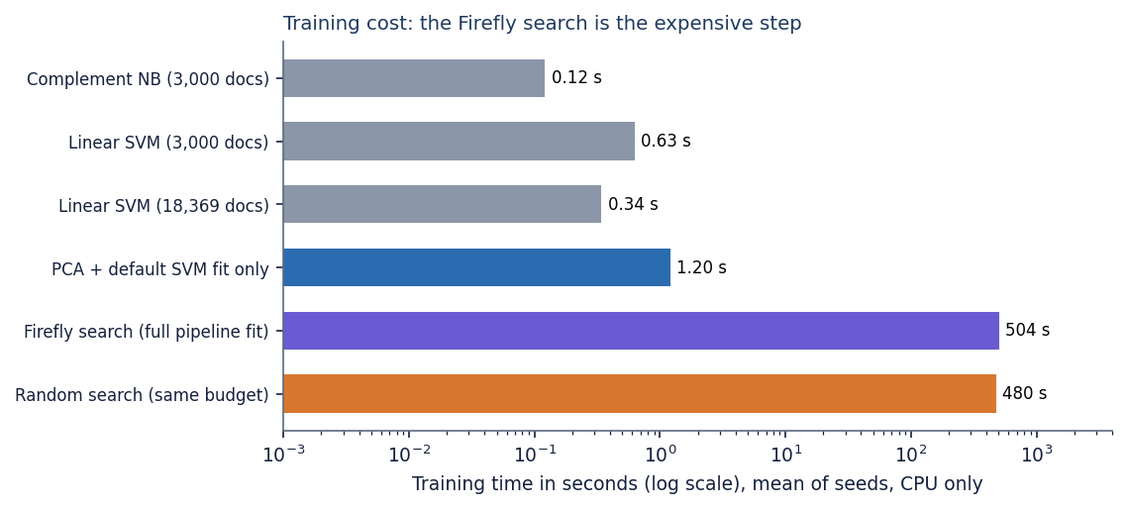
Figure 20: Training time of the pipeline stages and comparison models (log scale).
Not measured: memory use, concurrent requests, cold-cache start-up, any GPU run.

7.7 User interface testing
npm run build runs the TypeScript compiler over the whole interface and then bundles it; it passes with no type errors. The six screens were opened in Chrome with the LIAR2 model loaded and each completed its task (Section 7.4). The interface code splits every screen into its own chunk, loads charts only where used, and includes a light and a dark theme (both landing captures exist). Responsive layouts for narrow screens exist in the code (a navigation drawer below 1,024 px and a bottom bar), but they were not tested during this documentation run: only 1440 x 900 was captured.
Only Chrome was used. No automated component tests exist for the React code, the browser walk-through was a scripted capture rather than an assertion-based suite, and no accessibility audit was made.

7.8 User acceptance testing
No user acceptance test was performed. The project team used the application while it was built, but no group of readers, journalists or fact-checkers tried it and no questionnaire was used, so nothing is claimed about whether users find the verdicts useful or understandable. The functional walk-through of Section 7.4 stands in for it as a check that the intended tasks can be completed; it measures neither usability nor trust.

7.9 Defects and limitations found by testing
Testing with real data, unlike the shipped demo model, exposed behaviour that the earlier demonstrations could not show. These are reported as findings; no product code was changed.
Table 33: Findings
# | Finding | Evidence | Consequence
1 | The verdict and the displayed probabilities disagree | On 1,120 of 2,296 test statements (48.8%) the verdict is not the top-probability class; PARTIALLY TRUE is never the top class | The confidence shown can belong to another class than the verdict (see Chapter 8)
2 | load_csv misreads a label column holding only true / false | pandas parses the column as booleans, so true becomes 1 (PARTIALLY TRUE) and false becomes 0 (REAL) | ISOT-style files must be given REAL / FAKE words or 0 / 2 codes
3 | load_csv reads the numbers 0, 1, 2 as the project's classes | Numeric LIAR2 ids 3, 4, 5 would all become FAKE | Six-way ids must be mapped first, as the experiment script does
4 | Blank lines in a batch CSV are dropped silently | A 4-line file with two blank lines scores 2 rows | Row numbers in the results refer to the rows that were read
5 | Fixed interface text assumes the demo model | The landing page and Analytics note describe a "demo corpus" even when the LIAR2 model is loaded | A reader could misread the real-data scores as template scores
6 | One sensational-lexicon entry cannot match | "you wont believe" has three words but tokens are matched one at a time | Negligible effect on the 25 features

7.10 Limits of the testing done
• The tests establish that the code behaves as specified for the inputs tried; they do not establish that verdicts are correct. Correctness on real statements is measured in Chapter 8 and is modest.
• There is no load or concurrency test; latency figures are for one client on one idle machine and vary a little between runs.
• No cross-browser, mobile, accessibility, security-audit or user-acceptance testing was carried out (Sections 7.7 and 7.8).
• The 83 automated checks run against the shipped demo model or a model trained inside the test; the interface checks run against the LIAR2 model. No test compares the two models' behaviour.

CHAPTER 8: RESULTS AND OUTPUT SCREENS
This chapter shows the system running on real data and measures it. Section 8.1 gives the set-up, 8.2 the output screens, 8.3 the measurements, 8.4 the comparison with the base paper, 8.5 sample outputs with success and failure analysis, 8.6 the limits of the results and 8.7 the objectives against the outcomes. The results are modest, and where they fall short of the aims of the project the text says so.

8.1 Experimental set-up
The product ships a model trained on a synthetic template corpus (750 documents). Its own score of 1.000 macro-F1 only shows that the three template families are easy to tell apart, so every real measurement in this report uses LIAR2 [4], an extension of the LIAR benchmark [5] of short fact-checked statements, licensed under Apache-2.0. LIAR2 has an official split of 18,369 training, 2,297 validation and 2,296 test statements. Its six truthfulness labels are mapped to the three classes of the product with the mapping that src/dataset.py already contains: true and mostly-true become REAL, half-true becomes PARTIALLY TRUE, and barely-true, false and pants-on-fire become FAKE. Only the statement text is used; the speaker, the justification and the speaker's past counts are left out because they would leak the label. The test split then holds 602 REAL, 371 PARTIALLY TRUE and 1323 FAKE statements, so a classifier that always says FAKE reaches an accuracy of 0.576 and a macro-F1 of only 0.244.
The whole pipeline, as implemented in src/pipeline.py, was fitted on a stratified subsample of 3,000 training statements with 10 fireflies and 12 generations (the defaults of train.py), because the search needs several hundred SVM fits and the machine is CPU-only. Three seeds (2024, 42, 7) change the subsample, the 80/20 split inside the pipeline and the Firefly random numbers. Every model is scored on the full official validation and test splits. The measurements ran on Intel Core i5-12500 (6 cores, 12 threads, 3.0 GHz), 15.7 GB RAM, Windows 11 Pro, no GPU used; the software was Python 3.11.9, scikit-learn 1.9.1, NumPy 2.4.6, SciPy 1.17.1, pandas 3.0.6, FastAPI 0.159.1, uvicorn 0.54.0, Node 24.19.0, React 18.3, Vite 8, TypeScript 5.9, Tailwind CSS 4.
The main metric is macro-F1, the unweighted mean of the three per-class F1 scores, because a classifier that ignores the two minority classes can have a respectable accuracy and a useless macro-F1; accuracy, precision, recall and the confusion matrix are reported beside it. The models compared are the majority class, Complement NB, logistic regression and linear SVM on TF-IDF, the product's own unoptimised baseline (PCA with a default RBF SVM), a Firefly mask-only variant, random search with the same fitness and number of evaluations as Firefly, and the proposed pipeline.

8.2 Output screens
All screens are real captures (1440 x 900) of the TruthGlow web application, served by the FastAPI backend and the Vite frontend. The backend loaded the model trained on LIAR2 (3,000 statements, seed 42); the statements typed into Detect and uploaded to Batch check are real LIAR2 test statements chosen by scripts/capture_docs_screens.py (the most confident correct prediction of each class, 14 to 45 words), and Retrain was driven with a 600-row CSV from the LIAR2 training split, on a copy of the model file.

8.2.1 Landing page and About
  Figure 21: Landing page: tagline, live-demo card (clickbait example FAKE, 69.9 %) and the technique strip. |   Figure 22: About: the four pipeline steps, the three classes and the loaded model (3,000 documents, 4025 to 300 to 154 features, 48.67 % / 0.4134).

The landing page presents the product as a screening aid. Its "loaded model, by the numbers" strip is fixed wording written for the demo model and is inaccurate when a real-data model is loaded (limitation L10). The About page reads the loaded model's facts from the API.

8.2.2 Detect: verdicts on real statements
Detect takes an optional headline and the text (at least five words) and returns the verdict, confidence, three class probabilities, latency and cue words. The captures below show the result for one statement of each class; the statement is quoted in each caption.
  Figure 23: FAKE-labelled statement ("Photo shows Ron DeSantis holding a shirt that says, 'Your mask is as useless as Joe Biden.'"): verdict FAKE, 83.8 %, 26 ms. |   Figure 24: REAL-labelled statement ("In 1935, more than 50% of the elderly population lived in poverty. Today that poverty rate stands officially at 9.4%."): verdict REAL, about 54 %, 174 ms.

  Figure 25: Half-true statement about New Hampshire's unemployment rate: verdict PARTIALLY TRUE shown with 47.2 % confidence, while the tallest bar is FAKE. |   Figure 26: False statement about the signers of the Declaration of Independence: verdict REAL, 53.4 % - a wrong answer.

The first two verdicts agree with their labels and probabilities, with modest margins unlike the 99 % of the demo corpus. The third capture shows a real defect: the verdict comes from the class-weighted decision function and the bars from Platt scaling, so the confidence belongs to FAKE; on the 2,296 test statements the two disagree 1,120 times (48.8 %) (Section 8.3.5). The fourth is the central limit of the approach: a neutral-sounding historical claim cannot be checked, because the model sees only vocabulary, word pairs and style. The cue panels usually read "None found" because the cue lists are short fixed word lists.

8.2.3 Batch check
  Figure 27: Batch check after choosing liar2_test_sample.csv: 120 rows, 3 columns, first 10 rows previewed. |   Figure 28: Batch results: 120 articles screened (REAL 44, PARTIALLY TRUE 24, FAKE 52), distribution chart and results table.

The upload accepts a CSV of up to 25 MB, guesses the text column (statement) and shows ten rows; results can be downloaded with a verdict and confidence per row. The 40 statements of each class in the file were predicted as 44, 24 and 52, so PARTIALLY TRUE is under-predicted. The 6.28 s on screen was measured while the experiments used every CPU core; with an idle CPU 100 rows took 0.13 s and all 2,296 test statements 1.2 s (Section 8.3.6).

8.2.4 Model analytics
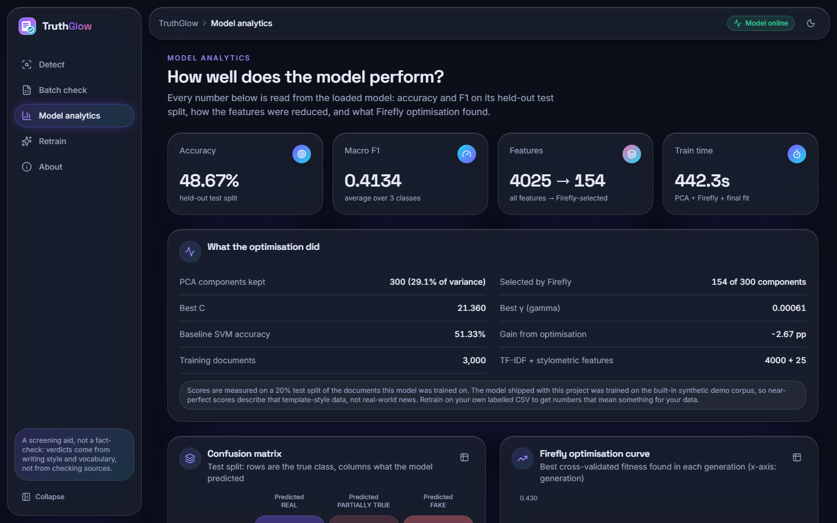  Figure 29: Analytics (top): accuracy 48.67 %, macro-F1 0.4134, features 4025 to 154, 442.3 s; PCA keeps 29.1 % of the variance; gain from optimisation -2.67 pp. | 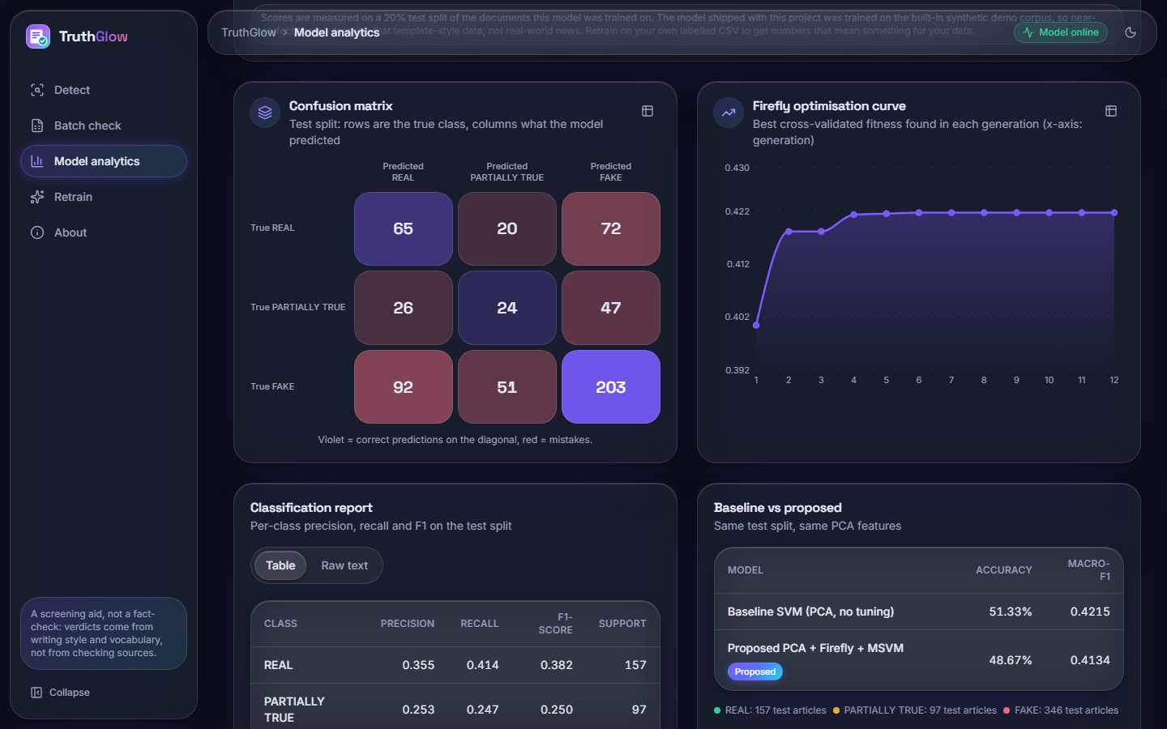  Figure 30: Analytics (charts): confusion matrix of the 600-statement hold-out, Firefly curve (0.392 to 0.422), classification report, baseline against proposed.

Every number is read live from the loaded model, on its own 20 % hold-out (600 of the 3,000 statements): confusion matrix [[65, 20, 72], [26, 24, 47], [92, 51, 203]]; F1 0.382 (REAL), 0.250 (PARTIALLY TRUE); the default SVM (51.33 %, macro-F1 0.4215) was slightly better than the optimised one. The official test-split results are in Section 8.3.

8.2.5 Retrain
Figure 31: Retrain: liar2_train_600.csv attached (71 KB), 4 fireflies, 3 generations, 4,000 TF-IDF features. |   Figure 32: Retrain finished: 600 documents, PCA 300 to 147 components, accuracy 42.50 %, macro-F1 0.4113, 199 s.

A labelled CSV (label as REAL, PARTIALLY TRUE, FAKE, 0 to 2 or LIAR names) and a Firefly budget start a background job; the page polls it and, when it ends, the new model replaces the loaded one without a restart. The confirmation dialog captured while the job starts (file 21) is in Appendix C. The small run scored lower than the 3,000-statement model, as expected from five times less data.

8.2.6 Captures of the shipped demo model
Files 01 to 09 in docs/screenshots/ show the same screens on the shipped demo model; they are in Appendix C. They report 99 to 100 % confidence on every example and a perfect confusion matrix (50, 50, 50), because the three classes are generated from three families of sentence templates.

8.3 Model performance

8.3.1 Headline results
The table gives accuracy, macro-F1 and weighted-F1 of every model on the 2,296 test statements as mean ± standard deviation over the three seeds (models trained on all 18,369 statements have no spread).
Table 34: Test-split scores on LIAR2, three classes (mean ± standard deviation over 3 seeds)
Model | Accuracy | Macro-F1 | Weighted-F1
Majority class (always FAKE) | 0.576 ± 0.000 | 0.244 ± 0.000 | 0.421 ± 0.000
Complement NB, TF-IDF, 3,000 statements | 0.584 ± 0.003 | 0.426 ± 0.010 | 0.551 ± 0.004
Logistic regression, TF-IDF, 3,000 | 0.554 ± 0.010 | 0.470 ± 0.011 | 0.563 ± 0.008
Linear SVM, TF-IDF, 3,000 | 0.560 ± 0.009 | 0.444 ± 0.009 | 0.551 ± 0.006
Complement NB, TF-IDF, all 18,369 | 0.599 ± 0.000 | 0.481 ± 0.000 | 0.588 ± 0.000
Logistic regression, TF-IDF, all 18,369 | 0.573 ± 0.000 | 0.500 ± 0.000 | 0.588 ± 0.000
Linear SVM, TF-IDF, all 18,369 | 0.575 ± 0.000 | 0.475 ± 0.000 | 0.575 ± 0.000
PCA + default RBF SVM | 0.505 ± 0.011 | 0.441 ± 0.010 | 0.522 ± 0.010
PCA + Firefly mask only | 0.481 ± 0.015 | 0.425 ± 0.014 | 0.502 ± 0.016
PCA + random search (same budget) | 0.494 ± 0.019 | 0.436 ± 0.009 | 0.514 ± 0.011
PCA + Firefly + MSVM (proposed) | 0.494 ± 0.008 | 0.429 ± 0.010 | 0.511 ± 0.007

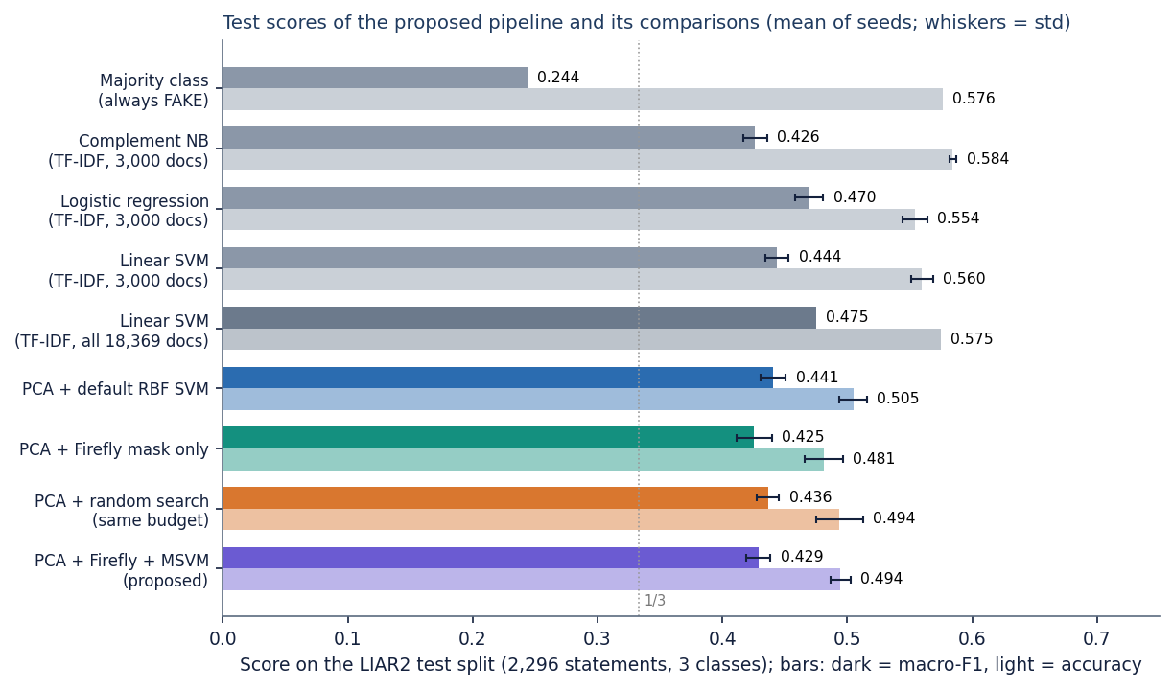
Figure 33: Test accuracy (light bars) and macro-F1 (dark bars) of the proposed pipeline and its comparisons; whiskers: standard deviation over seeds.
The proposed pipeline reaches a macro-F1 of 0.429 ± 0.010 and an accuracy of 0.494 ± 0.008; on the validation split it scores 0.501 ± 0.007 and 0.439 ± 0.010, so the test split is not an unlucky draw. Every real model beats the majority baseline on macro-F1 (0.244), so the features carry signal. Accuracy is a different story: the balanced class weights deliberately give up accuracy on the large FAKE class, so the proposed pipeline stays below the majority baseline's 0.576. The plain TF-IDF linear models are at least as good as the proposed pipeline: logistic regression on all statements reaches 0.500 macro-F1 and linear SVM 0.475.

8.3.2 Per-class results, confusion matrix and confidence
Table 35: Per-class test results of the proposed pipeline (mean ± std over 3 seeds)
Class | Precision | Recall | F1 | Test statements
REAL | 0.374 ± 0.009 | 0.474 ± 0.028 | 0.418 ± 0.011 | 602
PARTIALLY TRUE | 0.211 ± 0.011 | 0.276 ± 0.054 | 0.238 ± 0.023 | 371
FAKE | 0.714 ± 0.024 | 0.565 ± 0.026 | 0.630 ± 0.010 | 1323

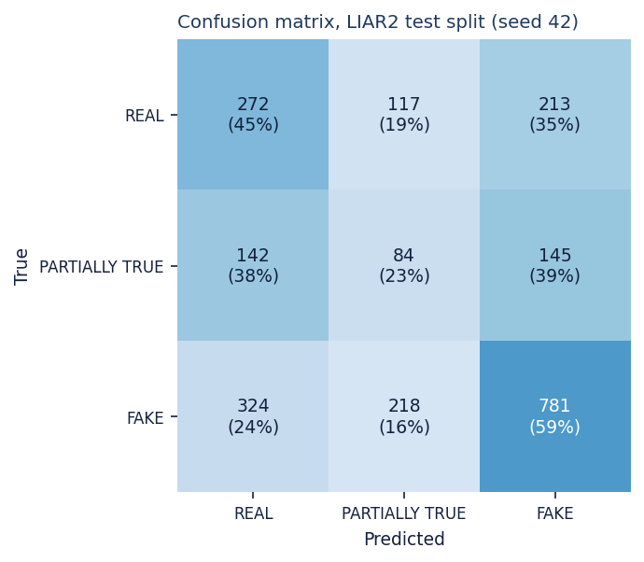  Figure 34: Confusion matrix of the test split, seed 42. | 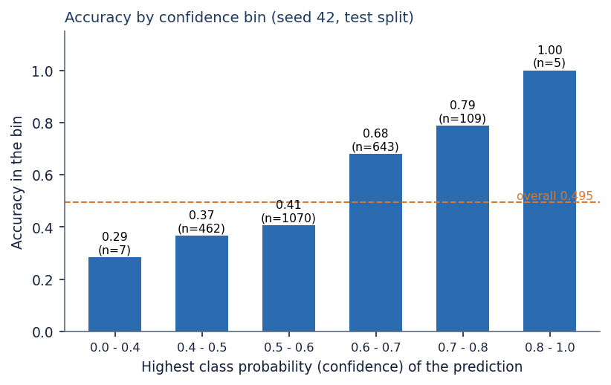  Figure 35: Accuracy by confidence bin (seed 42).

FAKE is recognised best (F1 0.630), REAL is a weak second (0.418) and PARTIALLY TRUE is near chance (F1 0.238). In the seed-42 matrix only 84 of 371 half-true statements are labelled PARTIALLY TRUE; 142 go to REAL and 145 to FAKE, and the largest error block is FAKE called REAL (324). The predicted class changes only gently along the original truthfulness scale: 209 of 303 pants-on-fire statements are called FAKE, but so are 84 of 259 true ones. Confidence does carry information: accuracy rises from 0.37 in the 0.4 to 0.5 bin to 0.68 and 0.79 in the 0.6 to 0.7 and 0.7 to 0.8 bins, but about two thirds of the statements fall in the two lowest bins. Accuracy also falls with statement length, from 0.56 below ten words to 0.43 for thirty words or more.

8.3.3 What the Firefly search did, and what it cost
Each search evaluates about 550 candidates (mask, C, gamma) by 3-fold cross-validation, keeps 148 ± 12 of 300 components and settles on C around 8.5 and gamma around 0.0010. The curves converge within about ten generations and the swarm beats random search on the training fitness (0.4334 against 0.4256), but the advantage disappears on the test split:
Table 36: Firefly search against its baselines, per seed (test macro-F1 and training-split fitness)
Seed | Firefly + MSVM | PCA + default SVM | Random search | Firefly fitness | Random fitness | Components kept
2024 | 0.433 | 0.451 | 0.439 | 0.4380 | 0.4271 | 156
42 | 0.418 | 0.440 | 0.444 | 0.4217 | 0.4199 | 154
7 | 0.436 | 0.431 | 0.426 | 0.4406 | 0.4299 | 134

Figure 36: Best Firefly fitness per generation; dotted lines: random search with the same budget. | Figure 37: Training time on a log scale (CPU only).

The proposed minus default-SVM difference is -0.018, -0.022 and +0.005 macro-F1 for the three seeds (mean -0.012); against random search the means are 0.429 and 0.436. With three seeds and a standard deviation of about 0.01 these differences are within noise and the sign is not stable; selecting components alone is worse than either (0.425). The Firefly algorithm tuned the fitness it was given, but a 3-fold macro-F1 on a few thousand noisy statements did not generalise better than an untuned SVM. One cause lies upstream: the PCA cap of 300 components keeps only 29.3 % of the variance on real text, against 95 % with 136 components on the demo corpus. Cost matters as much as score here: one fit took 504 ± 75 s (random search 480 s), the default SVM fit 1.20 s, and logistic regression and linear SVM on all statements 0.83 s and 0.34 s, so the optimised pipeline is about 1475 times more expensive to train than a linear SVM that scores better.

8.3.4 The shipped demo model on real statements
Applied to the same 2,296 test statements, the shipped model reaches an accuracy of 0.192 and a macro-F1 of 0.155, worse than always answering FAKE, and calls 2,044 statements PARTIALLY TRUE because that template class resembles hedged, neutral language.
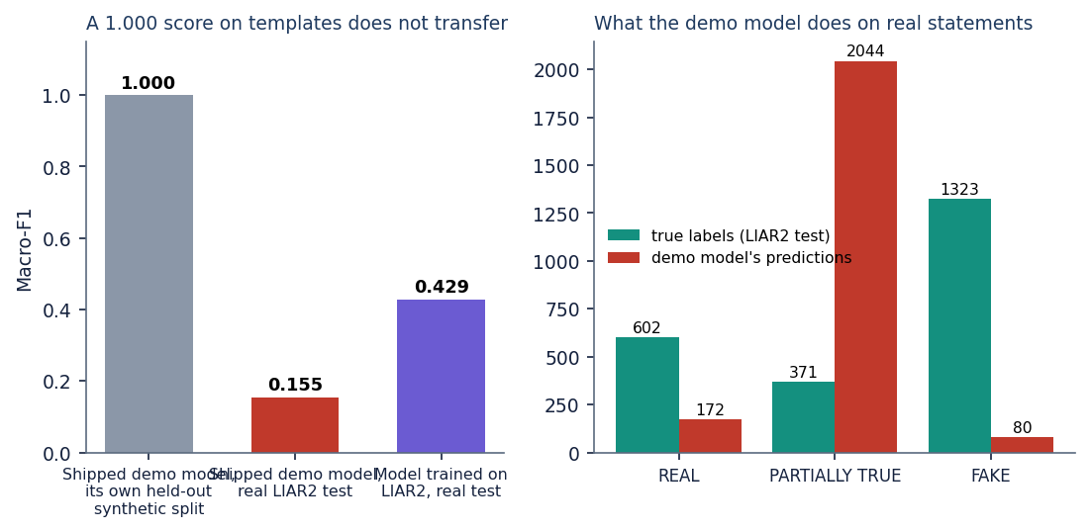
Figure 38: Left: macro-F1 of the demo model on its synthetic hold-out and on real LIAR2 statements, and of the LIAR2 model. Right: what the demo model predicts on the real test split.

8.3.5 Verdict against probabilities
The verdict is the SVM's predicted class (class-weighted decision function); the probabilities come from Platt scaling [12] fitted by internal cross-validation, which ignores the class weights. On the 2,296 seed-42 test statements the verdict is not the most probable class 1,120 times (48.8 %). The highest probability is FAKE for 2,252 statements, REAL for 44 and PARTIALLY TRUE for none, whereas the verdicts number 738, 419 and 1,139. Using the highest probability as the verdict would give an accuracy of 0.578 but a macro-F1 of 0.264, because it almost always answers FAKE. The confidence in the interface is the highest probability, so it can belong to another class than the verdict.
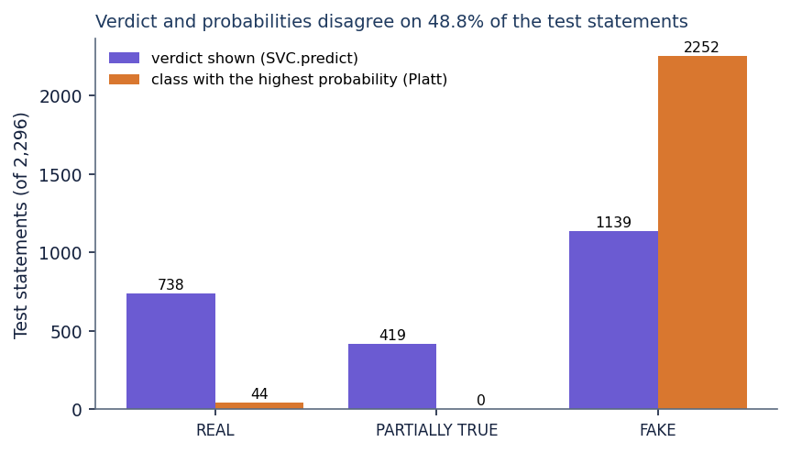
Figure 39: Test statements per class for the verdict shown (SVC.predict) and for the class with the highest Platt probability.

8.3.6 Response time, throughput and tests
The API was timed on 127.0.0.1 with the CPU idle (300 sequential requests after ten warm-up calls). The server-side time of POST /api/predict averaged 3.7 ms (95th percentile 5.3 ms) and the client round trip 12.6 ms; 2,296 statements took 1.2 s. 16 API smoke checks and 67 unit and edge-case checks (83 in all) pass (Chapter 7); they show correct behaviour, not accuracy.
Table 37: API response time and throughput (127.0.0.1, CPU idle, 300 sequential requests)
Measure | LIAR2 model (3,000 documents) | Shipped demo model (750 documents)
Start-up until /api/health answers | 6.1 s | 2.8 s
/api/predict, server time, mean / p95 | 3.7 / 5.3 ms | 2.2 / 3.8 ms
/api/predict, client round trip, mean / p95 / max | 12.6 / 29.8 / 76.7 ms | 9.7 / 27.7 / 31.8 ms
/api/batch/run, 100 / 1,000 rows | 0.13 / 0.55 s | 0.02 / 0.20 s
/api/batch/run, 2,296 rows | 1.20 s | 0.66 s

8.4 Comparison with the base paper
The base paper [1] combines CAMeLBERT embeddings, a neural network and class weighting for binary Arabic fake news detection and reports an accuracy of 95.52 % and an F1 of 96.19 %. These numbers cannot be compared with those of this project, as the table shows.
Table 38: The base paper and this project: what differs
Aspect | Base paper (Saad et al. 2026) | This project
Language and data | Arabic; 7,474 articles, part translated from LIAR and WELFake; 80/20 split | English; LIAR2 statements (18,369 / 2,297 / 2,296); official split
Task and text | Binary real/fake; news articles | Three classes (REAL, PARTIALLY TRUE, FAKE); statements of about 18 words
Features and classifier | CAMeLBERT embeddings; neural network with class weights | TF-IDF + 25 stylometric features, PCA; Firefly-tuned RBF SVM with balanced weights
Compute | Tesla T4 GPU | CPU only
Reported result | Accuracy 95.52 %, F1 96.19 % | Accuracy 49.4 %, macro-F1 42.9 % (three classes)

A binary Arabic collection with high labelling agreement (Fleiss' kappa 0.80) is an easier problem than three-way grading of one-sentence political claims. The comparison study [2] gives the scale for LIAR-style data: on LIAR-PLUS, collapsed to binary, logistic regression and an SVM reach an F1 of 0.56 and 0.57, and it is the hardest of ten datasets for nearly all models. A three-class macro-F1 of 0.43 to 0.50 is therefore not out of line, but not a number to set beside 96 %. Three lessons carry over: reporting several metrics together (here with macro-F1 and the confusion matrix, which matter more with three unbalanced classes); a TF-IDF baseline before anything fancier (the role of the linear models here); and class weighting against imbalance (visible here as accuracy below the majority baseline with macro-F1 far above it). Whether contextual embeddings, which gave the base paper about three points of accuracy over TF-IDF, would lift the LIAR2 scores was not tested.

8.5 Sample inputs and outputs, success and failure analysis
The table lists real test statements with the true class, the verdict and the probabilities for REAL, PARTIALLY TRUE and FAKE: three correct and four wrong cases from experiments/liar2/test_predictions_seed42.csv.
Table 39: Real test statements and the model's output (seed 42)
Statement | True class | Verdict | Probabilities R / PT / F | Result
Says Milken Institute rated San Antonio as nation's top-performing local economy. | REAL | REAL | 0.30 / 0.13 / 0.57 | correct
Expanding Medicaid would require borrowing more money, drastically expanding our deficit. | PARTIALLY TRUE | PARTIALLY TRUE | 0.12 / 0.22 / 0.66 | correct
Photo shows Ron DeSantis holding a shirt that says, "Your mask is as useless as Joe Biden. | FAKE | FAKE | 0.07 / 0.09 / 0.84 | correct
Says Melania Trump lied under oath in 2013 about graduating from college with a bachelor's degree in architecture. | REAL | FAKE | 0.13 / 0.14 / 0.73 | wrong
It's highly unusual to have a Supreme Court confirmation in a presidential election year. The last one was 1940. | PARTIALLY TRUE | FAKE | 0.15 / 0.07 / 0.78 | wrong
Pritzker and Madigan want to change the constitution to allow a permanent jobs tax on middle class families. | FAKE | REAL | 0.24 / 0.18 / 0.57 | wrong
The signers of the Declaration of Independence were "brave people, most of whom, by the way, were clergymen. | FAKE | REAL | 0.53 / 0.18 / 0.29 | wrong

The PARTIALLY TRUE verdict for the Medicaid statement sits beside a FAKE probability of about 0.66. The wrong cases are of different kinds: a true claim written in an accusatory style (Melania Trump), a half-true statement phrased as historical fact (the Supreme Court), and two false claims worded unremarkably (the jobs tax, the Declaration of Independence).

Where the system works
• The software works end to end on real data, with a few milliseconds per statement.
• FAKE is recognised with recall 0.57 and precision 0.71; accuracy is 0.68 to 0.79 for confidence above 0.6, where about 33 % of the statements lie.
• The pipeline is stable across seeds (standard deviation of macro-F1 0.010) and clearly above the majority class (0.429 against 0.244).

Where it fails
• PARTIALLY TRUE is almost not learned (F1 about 0.24); half-truths differ from falsehoods in content, not in vocabulary or style.
• The model cannot check facts: a well-phrased false claim is called REAL, and a true claim in an accusatory style is called FAKE; statements of thirty words or more reach only 0.43 accuracy.
• The optimiser and the PCA step add cost (about 504 s per fit) without a gain over default settings or linear models, and the displayed confidence does not belong to the verdict for 49 % of the statements.
• The shipped model, trained on templates, fails on real text (macro-F1 0.155) and must be replaced by a model trained on real labelled data before any use beyond a demonstration.

8.6 Limitations of these results
• Only 3,000 of 18,369 training statements were used for the pipeline; more data helps the linear models (logistic regression 0.470 with 3,000, 0.500 with all), and the full-data pipeline was not measured.
• Three seeds give a rough spread, not a significance test; differences of 0.01 macro-F1 should not be read as real.
• One dataset (one fact-checking organisation) was used; ISOT and cross-dataset transfer were not tested. The Firefly parameters and the PCA cap were not varied, and the three-class mapping (barely-true counted as FAKE) was not varied.
• Latency was measured on one machine with sequential requests; no load test and no user study were carried out.

8.7 Objectives against outcomes
Table 40: The six objectives of the project and what was achieved
No. | Objective | Status | Evidence
1 | Assemble a labelled dataset of genuine and fabricated news | Achieved for evaluation | LIAR2 (22,962 statements, three-class mapping) was obtained and used; the shipped model itself was trained on a 750-document synthetic corpus
2 | Preprocess: tokenisation, stop-word removal, stemming, vectorisation | Partly achieved | Cleaning, tokenisation, stop-word removal, TF-IDF with 1-2 grams and 25 stylometric features are implemented; stemming is not
3 | Apply PCA to reduce dimensionality | Achieved | 4,025 features reduced to at most 300 components; on real text the cap keeps only 29.3 % of the variance
4 | Use the Firefly algorithm to optimise feature selection and MSVM parameters | Implemented; benefit not shown | Joint search over mask, C and gamma keeps about 148 of 300 components; test macro-F1 (0.429) is not better than default SVM (0.441) or random search (0.436)
5 | Train a multi-class SVM on the optimised feature set | Achieved | RBF SVM, balanced class weights, three classes including PARTIALLY TRUE
6 | Evaluate accuracy, precision, recall and F1 against unoptimised baselines | Achieved | Reported against the majority class, default SVM, mask-only, random search and TF-IDF linear models; finding: no gain from optimisation
Aim | Improve accuracy and computational complexity while keeping the system reliable | Not achieved | Not better than simple baselines; training about 1475 times slower than a linear SVM
Aim | Deliver an easy-to-use application | Achieved | Six-screen web application with detection, batch, analytics and retraining; 83 automated checks pass

CHAPTER 9: CONCLUSION

9.1 Summary
The project set out to build a fake news detection system around a feature-based, optimised multi-class SVM: text features reduced by PCA, with the Firefly algorithm choosing features and parameters, and an explicit PARTIALLY TRUE class. The system was built and works end to end as a web application, a command-line tool and a Streamlit app over one library. It accepts a statement or a CSV, returns a verdict with a confidence, class probabilities and cue words, shows its own statistics and can be retrained on a user's labelled data.
The report measured the system honestly. The model shipped with the project was trained on a synthetic template corpus and scores 1.000 on its own hold-out, but only 0.155 macro-F1 on real statements. A model trained on 3,000 real LIAR2 statements reaches a macro-F1 of 0.429 ± 0.010 and an accuracy of 0.494 ± 0.008 on the 2,296 test statements, over three seeds.

9.2 Objectives achieved
• Achieved: a labelled dataset was obtained and mapped to three classes (objective 1, for evaluation); PCA reduces 4,025 features to at most 300 components (3); the Firefly algorithm is implemented and selects components and SVM parameters (4, implemented); an RBF multi-class SVM is trained on the selected features (5); accuracy, precision, recall and F1 are evaluated against unoptimised baselines (6).
• Partly achieved: preprocessing (2) covers cleaning, stop-word removal and vectorisation but not stemming.
• Not achieved: the aim of improving accuracy and computational cost. The optimised pipeline is not better than a default SVM or random search on the test split, and it is about 1475 times slower to train than a linear SVM that scores better.

9.3 Key findings
1. On real, short, fact-checked statements the three-class task is hard: macro-F1 is about 0.43, and the best simple model (logistic regression on all training statements) reaches 0.50.
2. The Firefly search improves its own training fitness over random search (0.433 against 0.426) but not the test score; on this data the optimiser does not pay for its cost of about 504 s per fit.
3. FAKE is recognised best (F1 0.63) and PARTIALLY TRUE worst (0.24); half-truths cannot be told apart by vocabulary and style.
4. Confidence is informative: accuracy rises from 0.37 for confidence between 0.4 and 0.5 to 0.79 between 0.7 and 0.8; but the verdict and the displayed probabilities disagree on 49 % of the statements.
5. A perfect score on a synthetic corpus says nothing about real text, and the PCA step keeps only 29 % of the variance on real text because of its cap.
6. The software is sound: 83 automated checks pass, a statement is classified in about 4 ms and 2,296 statements in about 1.2 s.

9.4 Practical applications
• A teaching and demonstration tool for a complete classical machine-learning pipeline (features, PCA, metaheuristic tuning, SVM) with a working interface and honest analytics.
• A screening aid that flags writing in a sensational or one-sided style for a human to look at, and a baseline for comparison with heavier models.
• A starting point for retraining on a newsroom's or a class's own labelled data through the Retrain screen.
• It is not suitable for deciding whether a claim is true, nor for moderation or legal decisions.

9.5 Known limitations
The main limitations are the synthetic shipped model (L1), the absence of any fact-checking (L2), the missing gain from the optimiser (L3), the weak PARTIALLY TRUE class (L4), the capped PCA (L5), the mismatch between verdict and probabilities (L6) and the small training subsample with few seeds (L7). The full list L1 to L13 is given in the document on scope and limitations.

CHAPTER 10: FUTURE SCOPE

10.1 Improvements to the model
1. Make the verdict and the probabilities consistent (untested): calibrate the probabilities with class priors taken into account, or derive both from the decision function, and show the calibrated confidence. This removes the mismatch of L6.
2. Remove the PCA cap or use incremental or truncated PCA on the sparse matrix without standardising it (untested), and measure the variance kept and the effect on the score (L5).
3. Train the pipeline on all 18,369 LIAR2 training statements, for example with a cheaper fitness (a subsample inside each fold) or a surrogate, and report the result with confidence intervals over more seeds (L7).
4. Tune the Firefly parameters (population, generations, alpha, beta0, gamma, penalty) and compare with Bayesian optimisation, as in the related work [3] (untested).
5. Add the missing preprocessing (stemming or lemmatisation) and measure each feature block separately (L9).
6. Try contextual embeddings as features, which the base paper found to add about three points of accuracy over TF-IDF [1] (untested here), possibly followed by the same PCA and Firefly steps to keep the classifier light.
7. Treat PARTIALLY TRUE as an ordinal rather than a nominal class, using the six original labels (for example ordinal regression), because the errors follow the truthfulness scale (Chapter 8).

10.2 Improvements to the application
• Show the verdict, the calibrated probabilities and a warning when the confidence is below a chosen level.
• Replace the fixed wording about the demo corpus by text read from the loaded model (L10), and fix the true/false label parsing in load_csv (L11).
• Explain a verdict by listing the TF-IDF terms and stylometric features that contributed most, in the spirit of LIME and SHAP used by the base paper.
• Support more languages by language-specific stop-word and cue lists.
• Export and import of models with version information, and keep a history of retraining runs.

10.3 Scalability and deployment
• Serve the backend with several worker processes behind a reverse proxy, add authentication and rate limits, and store models and retraining jobs outside the process (L12).
• Move retraining to a job queue so that long Firefly searches do not share the machine with the API.
• Run a load test and measure memory use; the model files are 0.85 MB (demo) and 12.6 MB (LIAR2, 3,000 documents) and load in a few seconds.
• Package the application as a container image for one-command deployment.

10.4 Further research
• Evaluate on several datasets and across datasets (ISOT, LIAR-PLUS, article-level corpora) and measure the transfer from one to another.
• Combine the text classifier with evidence retrieval so that a claim is checked against sources, which is what the present approach cannot do (L2).
• Study which metaheuristics help text classification at all, with equal budgets and many seeds, since this report found no gain for one of them.
• Run a user study on whether readers understand and trust a three-level verdict with a confidence.

REFERENCES
[1] M. Saad, S. Abdelrazek and I. R. Abdelmaksoud, "An algorithmic system for Arabic fake news detection using neural networks and transformer embeddings with class weighting," Scientific Reports, vol. 16, Art. no. 12226, 2026, doi: 10.1038/s41598-026-45653-4.
[2] P. Dell'Oglio, A. Bondielli, F. Marcelloni and L. C. Passaro, "An experimental comparison of the most popular approaches to fake news detection," Information Sciences, 2026, doi: 10.1016/j.ins.2026.123407; arXiv:2603.25501.
[3] T. Huang, Z. Xu, P. Yu, J. Yi and X. Xu, "A hybrid transformer model for fake news detection: Leveraging Bayesian optimization and bidirectional recurrent unit," 2025, arXiv:2502.09097.
[4] C. Xu and M.-T. Kechadi, "An enhanced fake news detection system with fuzzy deep learning," IEEE Access, vol. 12, pp. 88006-88021, 2024, doi: 10.1109/ACCESS.2024.3418340.
[5] W. Y. Wang, "'Liar, liar pants on fire': A new benchmark dataset for fake news detection," in Proc. 55th Annu. Meeting Assoc. Comput. Linguistics (ACL), Vol. 2: Short Papers, Vancouver, Canada, 2017, pp. 422-426, doi: 10.18653/v1/P17-2067.
[6] X.-S. Yang, "Firefly algorithms for multimodal optimization," in Stochastic Algorithms: Foundations and Applications (SAGA 2009), Lecture Notes in Computer Science, vol. 5792. Berlin, Germany: Springer, 2009, pp. 169-178.
[7] X.-S. Yang, "Firefly algorithm, stochastic test functions and design optimisation," Int. J. Bio-Inspired Computation, vol. 2, no. 2, pp. 78-84, 2010.
[8] C. Cortes and V. Vapnik, "Support-vector networks," Machine Learning, vol. 20, no. 3, pp. 273-297, Sep. 1995.
[9] C.-W. Hsu and C.-J. Lin, "A comparison of methods for multiclass support vector machines," IEEE Trans. Neural Netw., vol. 13, no. 2, pp. 415-425, Mar. 2002.
[10] I. T. Jolliffe and J. Cadima, "Principal component analysis: a review and recent developments," Phil. Trans. R. Soc. A, vol. 374, no. 2065, Art. no. 20150202, 2016.
[11] S. Wold, K. Esbensen and P. Geladi, "Principal component analysis," Chemometrics and Intelligent Laboratory Systems, vol. 2, nos. 1-3, pp. 37-52, 1987.
[12] J. C. Platt, "Probabilistic outputs for support vector machines and comparisons to regularized likelihood methods," in Advances in Large Margin Classifiers. Cambridge, MA, USA: MIT Press, 1999, pp. 61-74.
[13] G. Salton and C. Buckley, "Term-weighting approaches in automatic text retrieval," Information Processing & Management, vol. 24, no. 5, pp. 513-523, 1988.
[14] F. Pedregosa et al., "Scikit-learn: Machine learning in Python," J. Mach. Learn. Res., vol. 12, pp. 2825-2830, 2011.
[15] H. He and E. A. Garcia, "Learning from imbalanced data," IEEE Trans. Knowl. Data Eng., vol. 21, no. 9, pp. 1263-1284, Sep. 2009.
[16] K. Shu, A. Sliva, S. Wang, J. Tang and H. Liu, "Fake news detection on social media: A data mining perspective," ACM SIGKDD Explorations Newsletter, vol. 19, no. 1, pp. 22-36, 2017.
[17] S. Vosoughi, D. Roy and S. Aral, "The spread of true and false news online," Science, vol. 359, no. 6380, pp. 1146-1151, Mar. 2018.
[18] X. Zhou and R. Zafarani, "A survey of fake news: Fundamental theories, detection methods, and opportunities," ACM Comput. Surv., vol. 53, no. 5, Art. no. 109, 2020; arXiv:1812.00315.
[19] H. Ahmed, I. Traore and S. Saad, "Detection of online fake news using N-gram analysis and machine learning techniques," in Intelligent, Secure, and Dependable Systems in Distributed and Cloud Environments (ISDDC 2017), Lecture Notes in Computer Science, vol. 10618. Cham, Switzerland: Springer, 2017, pp. 127-138.
[20] V. Perez-Rosas, B. Kleinberg, A. Lefevre and R. Mihalcea, "Automatic detection of fake news," in Proc. 27th Int. Conf. Comput. Linguistics (COLING), Santa Fe, NM, USA, 2018, pp. 3391-3401.
[21] M. Potthast, J. Kiesel, K. Reinartz, J. Bevendorff and B. Stein, "A stylometric inquiry into hyperpartisan and fake news," in Proc. 56th Annu. Meeting Assoc. Comput. Linguistics (ACL), Melbourne, Australia, 2018, pp. 231-240.
[22] H. Rashkin, E. Choi, J. Y. Jang, S. Volkova and Y. Choi, "Truth of varying shades: Analyzing language in fake news and political fact-checking," in Proc. Conf. Empirical Methods in Natural Language Processing (EMNLP), Copenhagen, Denmark, 2017, pp. 2931-2937.
[23] J. Devlin, M.-W. Chang, K. Lee and K. Toutanova, "BERT: Pre-training of deep bidirectional transformers for language understanding," in Proc. NAACL-HLT, Minneapolis, MN, USA, 2019, pp. 4171-4186.
[24] B. Xue, M. Zhang, W. N. Browne and X. Yao, "A survey on evolutionary computation approaches to feature selection," IEEE Trans. Evol. Comput., vol. 20, no. 4, pp. 606-626, Aug. 2016.
[25] L. Zhang, K. Mistry, C. P. Lim and S. C. Neoh, "Feature selection using firefly optimization for classification and regression models," Decision Support Systems, vol. 106, pp. 64-85, 2018.
[26] Y. Al-Tarawneh, H. Kanj and W. Aly, "Enhancing fake news detection with word embedding: A machine learning and deep learning approach," Computers, vol. 13, no. 9, Art. no. 239, 2024.
[27] "Word embedding and classification methods and their effects on fake news detection," 2024. [Listed in the batch literature survey; authors and venue not verified.]
[28] "A deep learning ensemble framework for fake news stance detection and classification," Nanotechnology Perceptions, 2024. [Listed in the batch literature survey; authors not verified.]
[29] "Fake news detection using machine learning techniques," 2025. [Listed in the batch literature survey; authors and venue not verified.]
[30] "Analysis of fake news detection and prevention of various fake news detection algorithms and their research challenges," in Text and Social Media Analytics for Fake News and Hate Speech Detection, 2024. [Listed in the batch literature survey; authors not verified.]

APPENDIX A: IMPORTANT CODE
Excerpts from the repository (8.ProjectCode) in the state in which the results of this report were measured; the complete files are in src/ and backend/.

A.1 Text cleaning (`src/preprocessing.py`)
def clean_text(text: str) -> str:
if not isinstance(text, str):
return ""
t = text.lower()
t = _URL.sub(" ", t)
t = _MENTION.sub(" ", t)
t = t.replace("\n", " ")
t = _NON_ALPHA.sub(" ", t)
t = _WS.sub(" ", t).strip()
tokens = [w for w in t.split() if w not in STOPWORDS and len(w) > 2]
return " ".join(tokens)

A.2 Firefly fitness and main loop (`src/firefly.py`)
def _fitness(self, vec, X, y):
n_features = X.shape[1]
mask, C, g = self._decode(vec, n_features)
if mask.sum() < 2:
return 0.0
clf = SVC(C=C, gamma=g, kernel="rbf", class_weight="balanced",
decision_function_shape="ovr")
cv = StratifiedKFold(n_splits=self.cv, shuffle=True,
random_state=self.random_state)
try:
scores = cross_val_score(clf, X[:, mask], y, cv=cv,
scoring="f1_macro", n_jobs=-1)
f1 = float(np.mean(scores))
except Exception:
return 0.0
return f1 - self.penalty * (mask.sum() / n_features)
...
for gen in range(self.n_generations):
alpha_t = self.alpha * (0.97 ** gen) # decay randomness
for i in range(self.n_fireflies):
for j in range(self.n_fireflies):
if brightness[j] > brightness[i]:
r2 = float(np.sum((pop[i] - pop[j]) ** 2))
beta = self.beta0 * np.exp(-self.gamma * r2 / dim)
step = alpha_t * (rng.random(dim) - 0.5) * 2.0
pop[i] = pop[i] + beta * (pop[j] - pop[i]) + step
# keep hyperparam dims in range
pop[i][n_features] = np.clip(pop[i][n_features], -1, 3)
pop[i][n_features + 1] = np.clip(pop[i][n_features + 1], -4, 1)
brightness[i] = self._fitness(pop[i], X, y)
cur_best = int(np.argmax(brightness))
if brightness[cur_best] > self.best_score_:
self.best_score_ = float(brightness[cur_best])
best_vec = pop[cur_best].copy()
# elitist random walk of worst firefly
worst = int(np.argmin(brightness))
pop[worst] = best_vec + alpha_t * (rng.random(dim) - 0.5)
brightness[worst] = self._fitness(pop[worst], X, y)
self.history_.append(float(np.max(brightness)))

A.3 Pipeline: features, PCA and the final classifier (`src/pipeline.py`)
def fit(self, raw_texts, y, verbose=True):
t0 = time.time()
y = np.asarray(y)
cleaned = [clean_text(t) for t in raw_texts]
if verbose:
print(f"[1/5] Cleaned {len(cleaned)} docs")

self.vectorizer = TfidfVectorizer(max_features=self.max_tfidf,
ngram_range=(1, 2),
sublinear_tf=True,
min_df=2, max_df=0.9)
X_tfidf = self.vectorizer.fit_transform(cleaned)
X_style = stylometric_features(raw_texts)
X_full = hstack([X_tfidf, csr_matrix(X_style)]).toarray()
n_tfidf = X_tfidf.shape[1]
if verbose:
print(f"[2/5] Features: TF-IDF={n_tfidf} + stylometric=25 "
f"-> total {X_full.shape[1]}")

self.scaler = StandardScaler()
X_scaled = self.scaler.fit_transform(X_full)

# PCA — cap components for speed, keep target variance
pca_full = PCA(random_state=self.random_state)
pca_full.fit(X_scaled)
cumvar = np.cumsum(pca_full.explained_variance_ratio_)
n_keep = int(np.searchsorted(cumvar, self.pca_variance) + 1)
n_keep = max(10, min(n_keep, self.pca_max, X_scaled.shape[0] - 1,
X_scaled.shape[1]))
self.pca = PCA(n_components=n_keep, random_state=self.random_state)
...
# Final MSVM (multi-class SVC, OvR, balanced weights)
self.clf = SVC(C=self.optimizer.best_C_,
gamma=self.optimizer.best_gamma_val_,
kernel="rbf", class_weight="balanced",
decision_function_shape="ovr", probability=True,
random_state=self.random_state)
self.clf.fit(Xtr[:, mask], ytr)

A.4 Prediction endpoint (`backend/main.py`)
@app.post("/api/predict")
def predict(body: PredictBody):
full = (body.title + " " + body.text).strip()
if len(full.split()) < 5:
raise HTTPException(422, "Please enter at least a few words of news text (5 or more).")
pipe = get_pipe()
t0 = time.time()
ids, proba = pipe.predict([full])
latency_ms = (time.time() - t0) * 1000
label_id = int(ids[0])
result = {
"label": ID2LABEL[label_id],
"label_id": label_id,
"latency_ms": round(latency_ms, 1),
"cues": _cues(full),
"word_count": len(full.split()),
"confidence": None,
"probabilities": None,
}
if proba is not None:
probs = proba[0]
result["probabilities"] = {ID2LABEL[i]: float(p) for i, p in enumerate(probs)}
result["confidence"] = float(np.max(probs))
return result

A.5 Background retraining (`backend/main.py`)
def _retrain_worker(job_id, texts, y, fireflies, generations, max_tfidf):
job = _jobs[job_id]
try:
new_pipe = FakeNewsMSVMPipeline(max_tfidf=max_tfidf, n_fireflies=fireflies, n_generations=generations)
new_pipe.fit(texts, y, verbose=False)
os.makedirs(os.path.dirname(MODEL_PATH), exist_ok=True)
tmp = MODEL_PATH + ".tmp"
new_pipe.save(tmp)
os.replace(tmp, MODEL_PATH)
global _pipe
with _lock:
_pipe = new_pipe
s = new_pipe.stats_
job["result"] = {
"accuracy": s["accuracy"], "f1_macro": s["f1_macro"], "n_docs": s["n_docs"],
"n_selected": s["n_selected"], "n_pca": s["n_pca"], "train_time_s": s["train_time_s"],
}
job["status"] = "done"
except Exception as exc:
job["error"] = f"Training failed: {exc}"
job["status"] = "error"
finally:
job["finished"] = time.time()

APPENDIX B: INSTALLATION AND USER GUIDE

B.1 Requirements and start
• A Windows PC (measurements in this report: Intel Core i5-12500 (6 cores, 12 threads, 3.0 GHz), 15.7 GB RAM, Windows 11 Pro, no GPU used); no GPU. Python 3.11 or newer, Node.js 20 or newer, a current Chrome or Edge, and internet for the first installation.
• Double-click run.bat in 8.ProjectCode: it checks Python and Node.js, creates or rebuilds .venv, installs backend/requirements.txt and the frontend packages and starts both servers. The browser opens http://localhost:5406 (use localhost, not 127.0.0.1); the API runs on http://127.0.0.1:8406 (/docs). Ports are set in .env. Close the two minimised windows to stop.
• The backend loads models/msvm_model.pkl (about 3 s); if it is missing, a small demo model is trained first (about a minute). To use the LIAR2 model, set FAKENEWS_MODEL to models/liar2_msvm_model.pkl (or a copy) before starting; it is produced by scripts/run_experiments.py from the LIAR2 files train.csv, valid.csv, test.csv (huggingface.co/datasets/chengxuphd/liar2) placed in data/liar2/.
.venv\Scripts\python -m uvicorn backend.main:app --port 8406 # by hand, backend
cd frontend && npm install && npm run dev # by hand, frontend
python train.py --csv data/my.csv ; python predict.py --text "..." ; streamlit run app.py # CLI and Streamlit

B.2 Using the screens
1. Detect (/app): enter an optional headline and the text (at least five words), press "Detect fake news" or Ctrl+Enter; read the verdict, confidence, probability chart and cue words.
2. Batch check (/app/batch): drop a CSV (up to 25 MB, 20,000 rows), choose the text column, press "Run batch detection", inspect the table and download the results.
3. Model analytics (/app/analytics): accuracy, macro-F1, feature reduction, confusion matrix, Firefly curve and baseline comparison of the loaded model, on its own hold-out.
4. Retrain (/app/retrain): optionally attach a labelled CSV (text, optional title, label as REAL, PARTIALLY TRUE, FAKE, 0 to 2 or LIAR names), set fireflies (4 to 20), generations (3 to 30) and TF-IDF features (1,000 to 8,000), confirm and wait. Retraining replaces the loaded model and its file; keep a copy.
5. About (/app/about): the pipeline, the meaning of the verdicts and the facts of the loaded model.

B.3 Checks and troubleshooting
scripts/smoke_test.py (16 API checks), scripts/unit_edge_tests.py (34 library and 33 API checks), npm run build (type check and build), scripts/run_experiments.py, scripts/measure_api.py and scripts/capture_docs_screens.py (screenshots, app running).
Table 41: Common problems
Symptom | Cause and remedy
"Can't reach the detection API" or a blank page | Backend not running, or page opened on 127.0.0.1: run run.bat, open http://localhost:5406
Pickle or scikit-learn error when loading the model | The model was saved by scikit-learn 1.9: use the packages run.bat installs, or retrain
HTTP 422 / 400 / 413 / 409 | Fewer than five words / unreadable or empty CSV or no label column / more than 20,000 rows or 25 MB / a retraining job is running
Odd verdicts after retraining on true/false labels | pandas reads a label column of only true/false as booleans (limitation L11): use REAL / FAKE or 0 / 2
Port already in use | Change BACKEND_PORT / FRONTEND_PORT in .env

APPENDIX C: ADDITIONAL SCREENS
Captured by the frontend build on the shipped demo model, trained on the synthetic template corpus: the interface is faithful, but confidences of 99 to 100 % and an accuracy of 100 % describe template-style data, not real news. Captures on the LIAR2 model are in Chapter 8; the last pair below adds the retraining confirmation (file 21) and the demo model's analytics charts.
  Figure 40: Landing page, dark theme (demo model). |   Figure 41: Landing page, light theme; the demo card scores the clickbait example FAKE, 89.5 %.

  Figure 42: "How it works": step 2 of 4, compress with PCA. |   Figure 43: Detect: clickbait example FAKE, 99.4 %, 2 ms.

  Figure 44: Batch check on six demo articles: two per class, 99 to 100 %. |   Figure 45: Analytics: accuracy 100 %, 596 to 57 features, PCA 136 components (95.2 %), 750 documents.

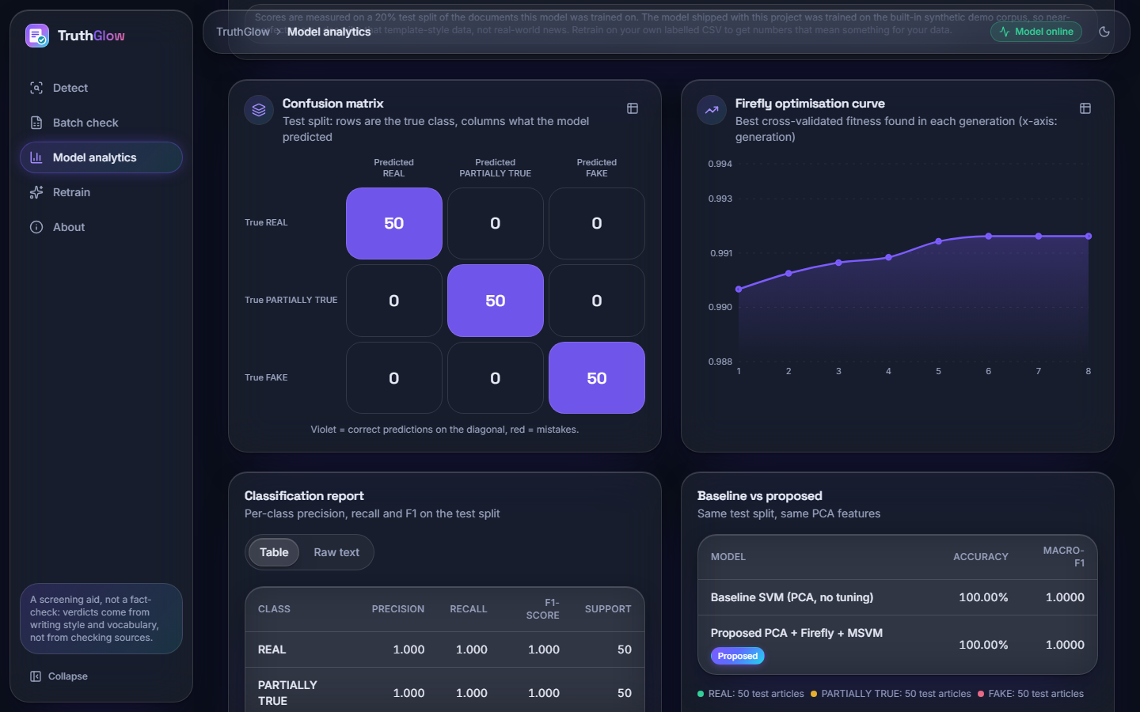  Figure 46: Analytics charts: perfect confusion matrix (50, 50, 50). |   Figure 47: About screen of the demo model.

  Figure 48: Retrain: a 60-row CSV, 10 fireflies, 6 generations. |   Figure 49: Retrain running: 60 rows, 10 x 6 evaluations.

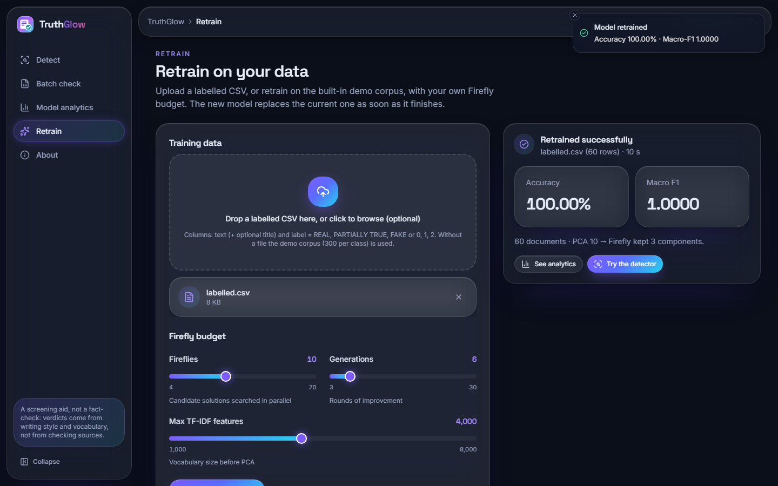  Figure 50: Retrain finished: PCA 10 components, Firefly kept 3, 100 %, 10 s. |   Figure 51: LIAR2 retrain: the confirmation dialog "Replace the current model?" while the job starts.

